# 

# 

# 

# C:\Users\OLIVER~1\AppData\Local\Temp\ksohtml14012\wps25.png C:\Users\OLIVER~1\AppData\Local\Temp\ksohtml14012\wps23.png C:\Users\OLIVER~1\AppData\Local\Temp\ksohtml14012\wps26.png

# 

# 

# Table of Contents

1. Introduction  
   1.1 Overview of the Liquor Licensing Board System  
   1.2 Purpose of the User Manual  
   1.3 Accessing the Liquor Licensing Board (LLB) System  
   1.4 Home/Landing Page  
   1.5 Services of Liquor Licensing Board Page  
   1.6 About Liquor Licensing Board Page  
   1.7 Contact Page
2. User - Client  
   2.1 Registering for an Account  
   2.2 Logging In to Your Account  
   2.3 Managing Liquor Licenses (Dashboard Overview)  
   2.4 Confirming and Completing License Owner's Details  
   2.5 Selecting Applicant Type  
   2.6 Providing Outlet Information  
   2.7 Adding Director Information  
   2.8 Reviewing Director Information  
   2.9 Adding Manager Information  
   2.10 Uploading Required Attachments  
   2.11 Finalizing Application and Payment  
   2.12 Tracking Application Status  
   2.13 Accessing Approved Licenses
3. Accountant  
   3.1 Accountant Dashboard Overview  
   3.2 Changing Your Password  
   3.3 Managing Payments  
   3.4 Verifying Manual Payments
4. Verifier  
   4.1 Verifier Dashboard Overview  
   4.2 Verifying Applicant Information  
   4.3 Application Verification and Approval
5. Recommender  
   5.1 Recommender Dashboard Overview  
   5.2 Reviewing and Recommending Applications  
   5.3 Approving Applications
6. Secretary  
   6.1 Secretary Dashboard Overview  
   6.2 Managing License Types  
   6.3 Managing License Regions  
   6.4 Final Application Approval or Rejection
7. Administrator  
   7.1 Admin Dashboard Overview  
   7.2 User Management  
   7.3 Task Management  
   7.4 Council Management  
   7.5 Managing License Fees  
   7.6 Bulk Task Reassignment  
   7.7 Registering Internal Users  
   7.8 Viewing Internal Users

# 1. Introduction

#### 1.1 Overview of the Liquor Licensing Board System

The Liquor Licensing Board (LLB) system is an online platform designed to streamline the liquor licensing process, ensuring efficient and transparent processing of applications. It enables users to apply for, track, and manage liquor licenses digitally, reducing paperwork and enhancing accessibility.

#### 1.2 Purpose of the User Manual

This manual provides guidance for users, including clients, accountants, and administrators, on how to navigate and utilize the LLB system efficiently.

#### 1.3 Accessing the Liquor Licensing Board (LLB) System

To access the Liquor Licensing Board (LLB) system and manage your liquor license applications online, follow these simple steps:

1. Open your web browser: You can use any popular web browser such as Chrome, Firefox, Safari, or Edge.
2. Ensure a stable internet connection: A reliable internet connection is crucial for seamless access and interaction with the LLB system.
3. Type the website address: In the address bar of your browser, carefully type the following URL: <https://llb.pfms.gov.zw/> and press Enter.
4. LLB homepage: This will take you to the official LLB homepage, where you can access various sections and information related to liquor licensing.
5. Login or Register: If you already have an account, click on the "LOGIN" button and enter your credentials. If you are a new user, click on "REGISTER" to create an account.
6. Explore the dashboard: Once logged in, you will be directed to your user dashboard, where you can manage your applications, access resources, and interact with the LLB system.

#### 1.4 HOME/ LANDING PAGE

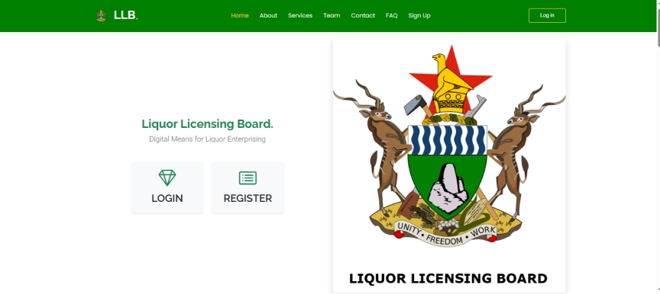

The Liquor Licensing Board (LLB) website serves as the central digital platform for all liquor licensing activities. Upon accessing the site, users are greeted with a clean and intuitive homepage designed for easy navigation.

At the top, a prominent green navigation bar provides quick access to key sections: "Home," "About," "Services," "Team," "Contact," "FAQ," "Sign Up," and "Log In." This ensures that users can readily find the information or action they need.

The website's header clearly displays the "LLB" logo, reinforcing the official nature of the platform. Below the logo, the tagline "Liquor Licensing Board. Digital Means for Liquor Enterprising" highlights the site's purpose and its commitment to modernizing the licensing process.

Two prominent buttons, "LOGIN" and "REGISTER," are centrally located, guiding users to either access their existing accounts or create new ones. These buttons are designed with clear icons (a diamond for login and a list for register) for visual clarity.

On the right side of the page, the Coat of Arms of Zimbabwe is prominently displayed. This symbol underscores the official government affiliation of the Liquor Licensing Board. Below the coat of arms, the text "LIQUOR LICENSING BOARD" is repeated, further emphasizing the site's official status.

The website's design is straightforward, prioritizing ease of use and accessibility. The combination of clear navigation, prominent action buttons, and official symbols ensures that users can efficiently manage their liquor licensing needs.

#### 1.5 SERVICES OF LIQUOR LICENSING BOARD PAGE

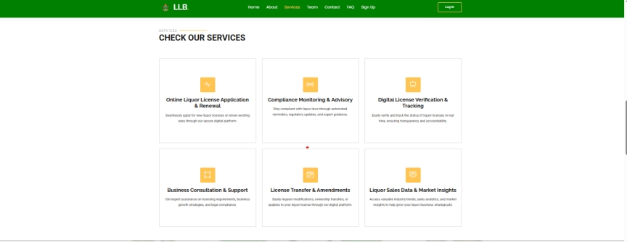

#### 

#### 1.6 ABOUT LIQUOR LICENSING BOARD PAGE

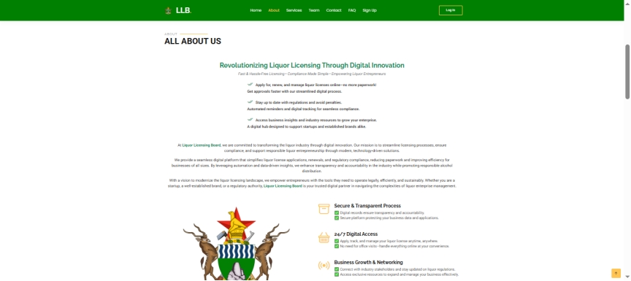

The green navigation bar at the top provides access to various sections of the website. "ALL ABOUT US" is prominently displayed.

The page highlights the LLB's mission to revolutionize liquor licensing through digital innovation, emphasizing a streamlined process and compliance.

It lists benefits such as applying for licenses online, staying updated with regulations, accessing industry resources, and a commitment to supporting businesses.

The LLB emphasizes secure and transparent processes, 24/7 digital access, and business growth & networking opportunities.

The Coat of Arms of Zimbabwe is displayed at the bottom, signifying the official government affiliation.

The page aims to present the LLB as a modern, efficient, and supportive organization dedicated to improving the liquor licensing experience through digital solutions.

1.7 CONTACT PAGE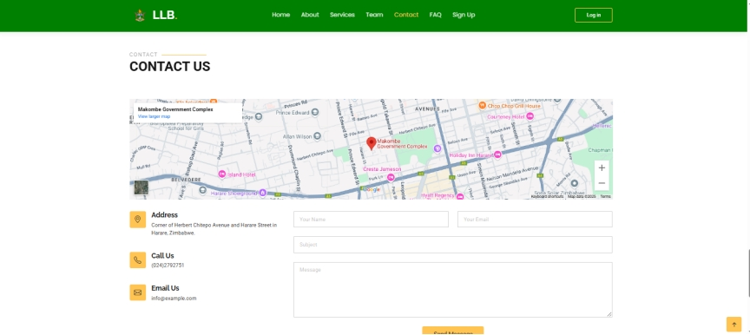

This image depicts the "Contact Us" page of the Liquor Licensing Board (LLB) website for Harare, Zimbabwe.

Green navigation bar at the top for easy access to website sections. And "CONTACT US" is prominently displayed.

Location: Makombe Government Complex is highlighted on a Google Map.

Address: Corner of Herbert Chitepo Avenue and Harare Street, Harare, Zimbabwe.

Contact Information:

Call Us: (024) 2792751

Contact Form:

Fields for "Your Name," "Your Email," "Subject," and "Message."

"Send Message" button.

Map: A google map is embedded on the page to show the location of the Makombe Government Complex.

# User -Client

#### 2.1 Registering for an Account on the Liquor Licensing Board Website

**REGISTER FORM/PAGE**

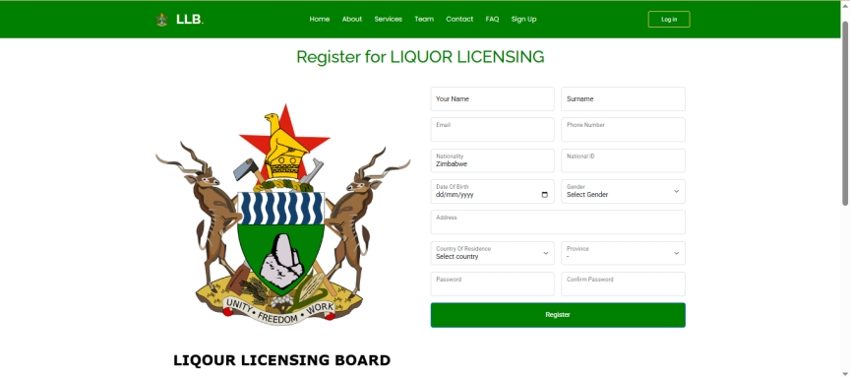

This section guides you through the process of creating a new account on the Liquor Licensing Board (LLB) website.

To register for liquor licensing, provide your name, email, phone number, nationality,ID/passport number, date of birth (DD/MM/YYYY), gender, address, country, province, and a strong password.

Provide a valid email address in the"Email" field, as this will be used for communication and account verification,

Create a strong password, such as Chaplin@1, which includes characters and numbers, and enter it in both the "Password" and "Confirm Password" fields to ensure they match.

After filling in all the required fields, click the "Register" button to submit your registration.

Upon successful completion of the registration form, you will see a confirmation message stating "Your account has been successfully created," confirming that your registration was successful.

After successfully registering your account on the Liquor Licensing Board (LLB) website, you will be able to log in and access the platform's services.

#### 2.2 Logging In to Your Liquor Licensing Board Account

LOGIN FORM/PAGE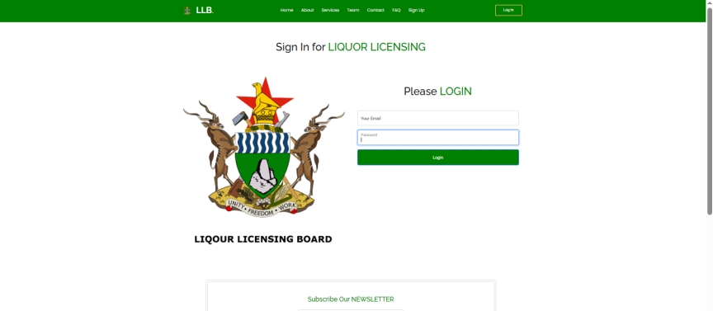

Upon successful registration, you'll be automatically redirected to the login page. Alternatively, you can access it anytime by clicking the "Log In" button in the top right corner.

To log in, enter the email address you used during registration in the "Your Email" field and the corresponding password in the "Password" field. Clicking the "Login" button will then attempt to authenticate your credentials.

A successful login, indicated by correct email and password entry, will redirect you to your account dashboard, providing access to LLB's services and features.

Conversely, incorrect credentials will trigger an error message, prompting you to re-enter your login details. Once logged in, the dashboard serves as your central hub for managing applications and accessing vital information.

#### 2.3 Your Dashboard: Managing Liquor Licenses

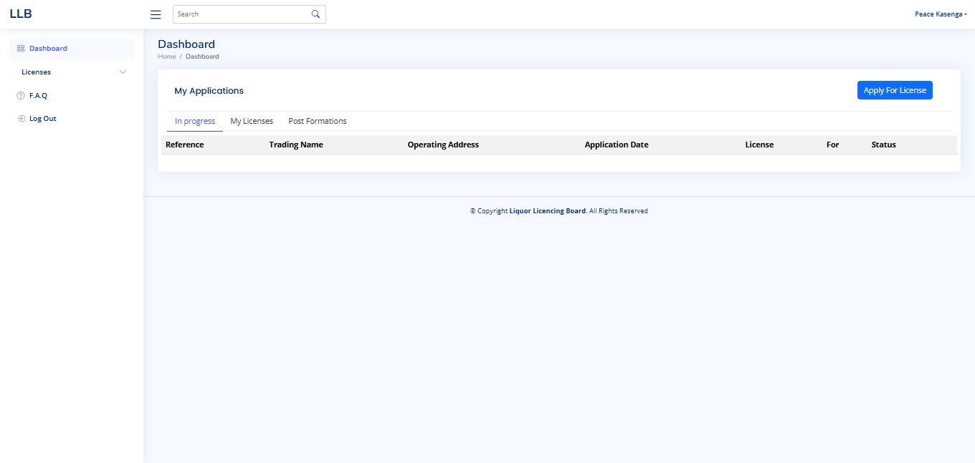

This page is your main screen when you log in to the Liquor Licensing Board (LLB) system. It gives you quick access to your license applications and existing licenses.

#### Here's what you'll see and how to use it:

1. **Your Applications and Licenses:**
   * The main part of the page lists your applications. You'll see:
     + **"In Progress" Applications:** These are applications you've started but haven't finished.
     + **"My Licenses":** This shows the licenses you have already been approved for.
     + **"Post Formations":** (We'll explain this in detail later. It's likely for updates to your licenses after they're approved, like changes to your business address .)
2. **Applying for a New License:**
   * Click the blue "Apply For License" button to start a new application.
3. **Application/License Information:**
   * The table shows important details:
     + **Reference Number:** A unique number for each application.
     + **Trading Name:** The name of your business.
     + **Operating Address:** The physical address of your business. **Please ensure this is accurate.**
     + **Application Date:** When you submitted the application.
     + **License Type:** The type of liquor license (e.g., bottle store, bar).
     + **"For":** (We'll explain this later. It might indicate the purpose of the license, like "Retail" or "Wholesale.")
     + **Status:** The current status of your application (e.g., "Pending," "Approved").
4. **Navigation:**
   * Use the menu on the left side of the screen to go to other sections like:
     + "Licenses" to manage your existing licenses.
     + "FAQ" for answers to common questions.
     + "Log Out" to exit the system.
   * Use the search bar at the top to find specific applications or information.
5. **Your Account:**
   * Your name ("Peace Kasenga" in the image) is displayed at the top right.

#### 2.4 Confirming and Completing the License Owner's Details

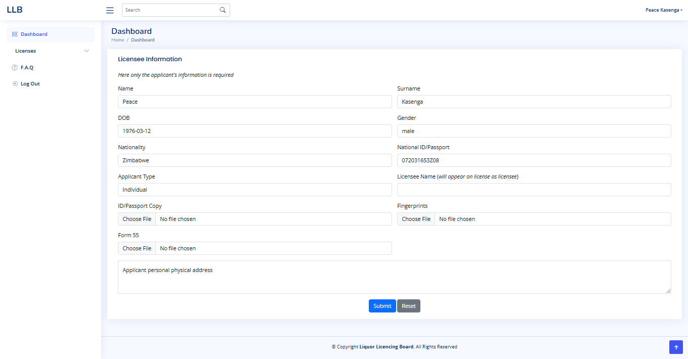

1. **Review Pre-filled Details:** Your name, date of birth, gender, nationality (Zimbabwe), and National ID are automatically shown. This information comes directly from your registration. Verify these details are correct.
2. **Upload ID/Passport:** Click "Choose File" to upload a clear copy of your National ID or Passport.
3. **Upload Fingerprints:** Click "Choose File" to upload a clear copy of your fingerprints.
4. **Upload Form 55:** Click "Choose File" to upload your completed Form 55 (applicable to your region).
5. **Enter Your Physical Address:** Type your full physical address where you live in the "Applicant personal physical address" box.
6. **Submit:** Click "Submit" to save your information.
7. **Reset Address:** Click "Reset" to clear only the address field.
8. **Important:** The pre-filled details cannot be changed here. Contact the Liquor Licensing Board if you find errors in your registration information.

#### 2.5 Selecting Your Applicant Type

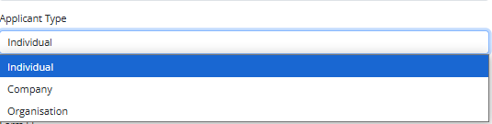

1. **Applicant Type Dropdown:** This dropdown allows you to specify what type of entity is applying for the liquor license.
2. **Options:**
   * **Individual:** Select this if you are applying for the license in your own name as a sole proprietor.
   * **Company:** Select this if a registered company is applying.
   * **Organisation:** Select this if a registered organization (e.g., club, association) is applying.
3. **Impact on Next Steps:**
   * **Individual:** If you select "Individual," you will proceed to provide your personal details and upload required documents.
   * **Company or Organisation:** If you select "Company" or "Organisation," you will be required to provide additional information in the next step, such as:
     + Details of the company or organization's directors/officials.
     + Registration documents.
     + Other relevant documentation.
4. **Choosing Correctly:** Please select the option that accurately reflects the nature of the applicant. This will ensure you provide the correct information and documentation for your liquor license application
5. **Assistance:** If you are unsure which option to select, please contact the Liquor Licensing Board for assistance.

**Confirmation and Updating Your License Owner's Details**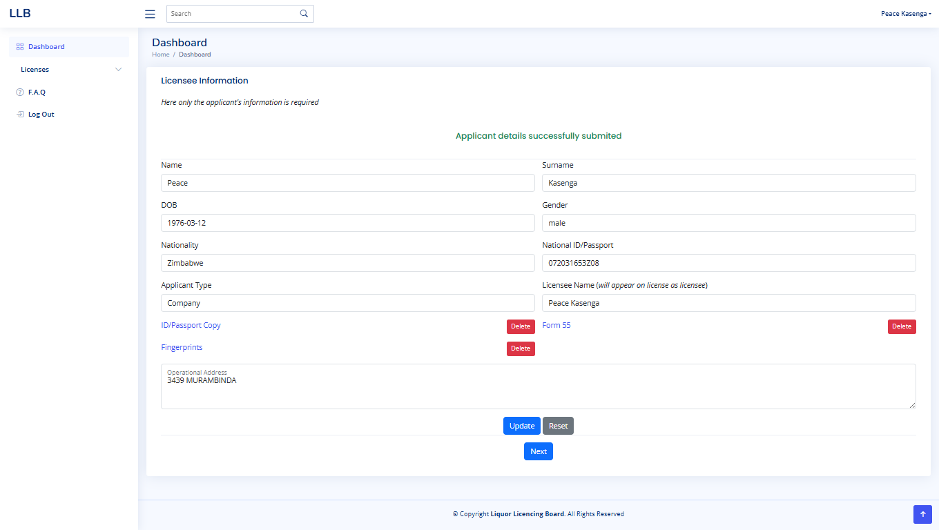

1. **Submission Message:** After you click "Submit," you will see the message "Applicant details successfully submitted" at the top of the page. This confirms that your information has been saved.
2. **Updating Information:** If you need to make changes to your details, you can do so on this page.
   * **Uploaded Documents:** You can delete and re-upload your ID/Passport Copy, Fingerprints, and Form 55 by clicking the "Delete" and "Choose File" buttons respectively.
   * **Operational Address:** You can change your operational address in the "Operational Address" box.
3. **Saving Changes:** After making any changes, click the "Update" button to save them.
4. **Reset:** If you want to clear the changes you made to the Operational Address, click the "Reset" button.
5. **Proceeding to the Next Step:** Once you have confirmed that all the information is correct, click the "Next" button to move to the next stage of the application process.
6. **Important:** Remember that the pre-filled information (name, date of birth, etc.) is from your registration and cannot be changed on this page. Contact the Liquor Licensing Board if you need to update your registration details.

#### 2.6 Providing Your Outlet Information

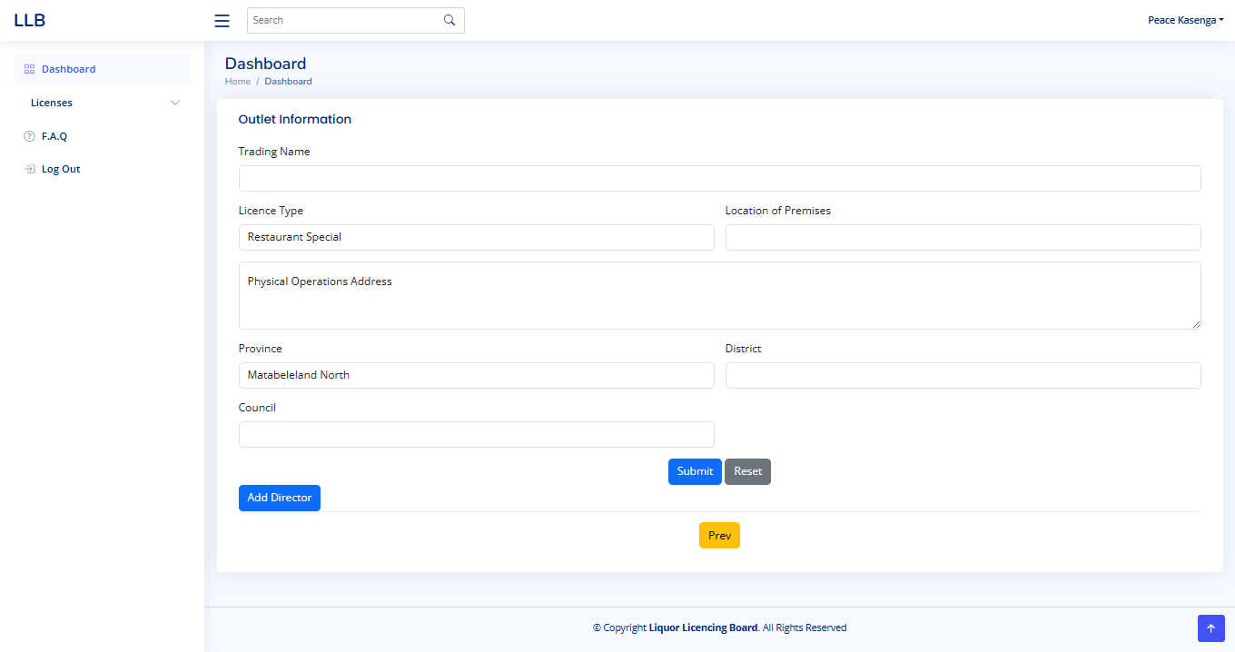

1. **Trading Name:** Enter the official name of your business or establishment.
2. **License Type:** Select the appropriate license type from the dropdown menu. In this case, "Restaurant Special" is pre-selected.
3. **Location of Premises:** Enter the general location of your business (e.g., street name, area).
4. **Physical Operations Address:** Provide the full physical address of your business.
5. **Province:** Select the province where your business is located. In this case, "Matabeleland North" is pre-selected.
6. **District:** Enter the district where your business is located.
7. **Council:** Enter the name of the local council under whose jurisdiction your business falls.
8. **Add Director (If Applicable):** If your business is a company or organization, click the "Add Director" button to provide details of the directors.
9. **Submit:** Once you have filled in all the required information, click the "Submit" button to save.
10. **Reset:** If you need to clear the information you entered, click the "Reset" button.
11. **Previous:** If you need to go back to the previous step, click the "Prev" button.

**Important:** Please ensure that all the information provided is accurate and complete.

#### 2.7 Adding Director Information

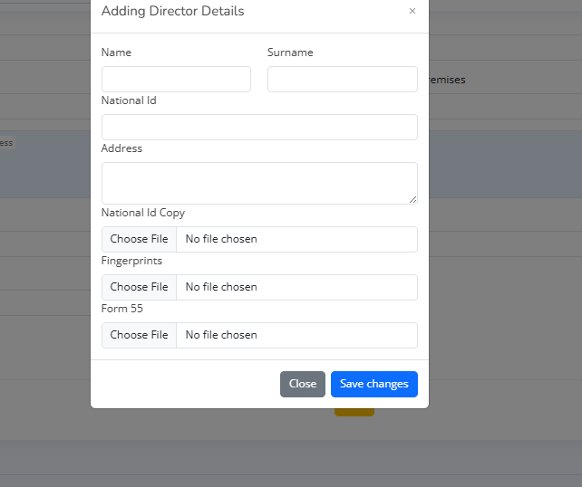

For Companies/Organizations, click "Add Director" to open this form.

* **Enter Director Details:** Fill in the director's name, National ID, and address.
* **Upload Documents:** Upload copies of the director's National ID, fingerprints, and Form 55 (Beitbridge Form 55).
* **Save:** Click "Save Changes" to add the director.
* **Cancel:** Click "Close" to exit without saving.

**Important:** Ensure all details and documents are accurate.

#### 2.8 Reviewing Director Information and Proceeding

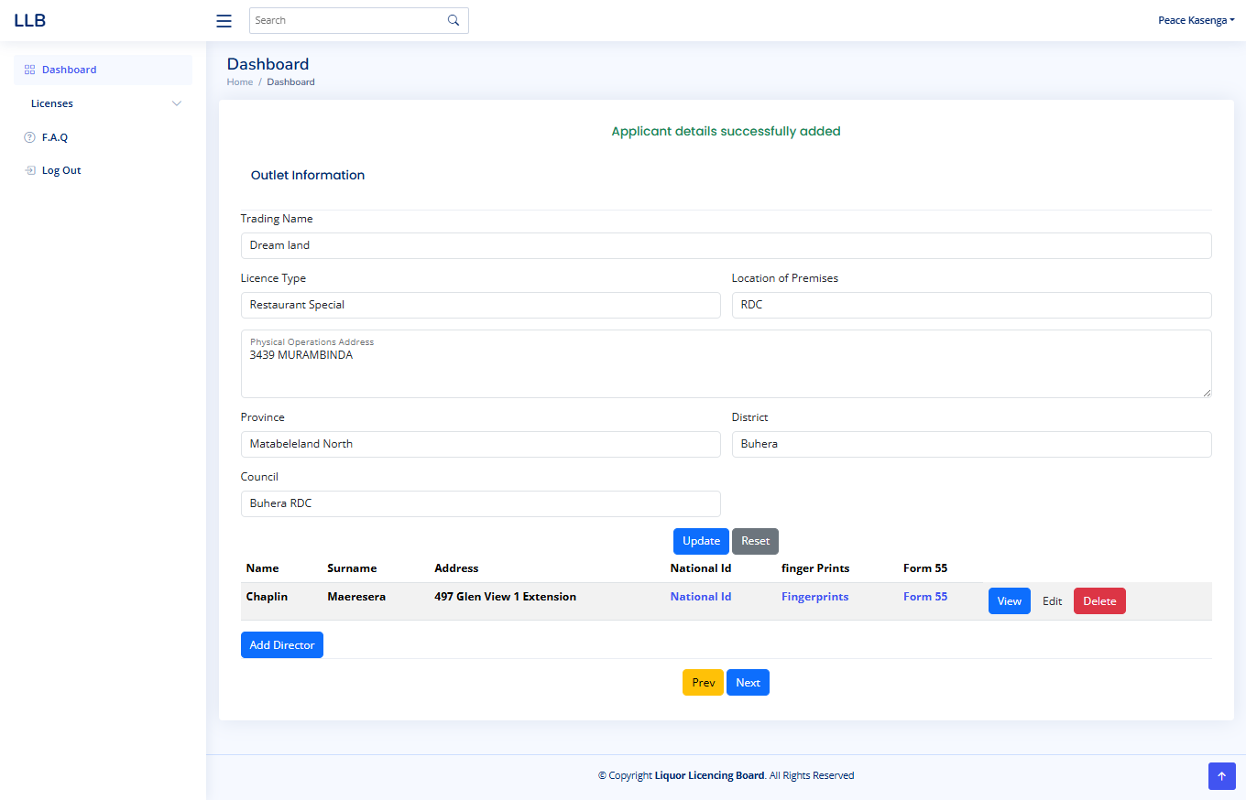

After adding a director, their details will appear in a table below the "Outlet Information."

* **Director Details:** The table shows the director's name, address, National ID, and uploaded documents (fingerprints and Form 55).
* **Actions:** You can "View," "Edit," or "Delete" the director's information using the buttons provided.
* **Adding More Directors:** If you need to add more directors, click the "Add Director" button again.
* **Updating Outlet Information:** If you need to make changes to the outlet information, click the "Update" button.
* **Resetting Changes:** If you need to clear the changes you made, click the "Reset" button.
* **Previous Step:** Click "Prev" to go back to the previous step.
* **Next Step:** Once you have reviewed the director's details and ensured all information is correct, click "Next" to proceed to the next stage of the application process.

**Important Notes:**

* **Accuracy:** Double-check all director details and uploaded documents.
* **Form 55:** Ensure the Form 55 is the correct version for your location.
* **Contact:** If you have any questions or need assistance, contact the Liquor Licensing Board.

#### 2.9 Manager Details

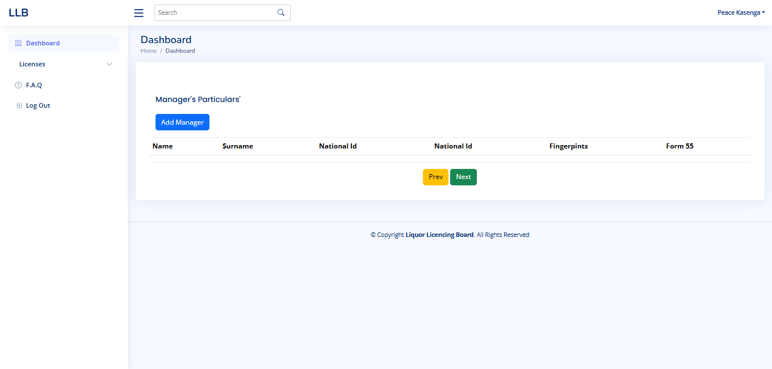

* Click "Add Manager" to enter manager information.
* The table will show manager's name, ID, and documents.
* Click "Prev" to go back or "Next" to continue.
* Ensure all information is accurate.

#### Adding Manager Information

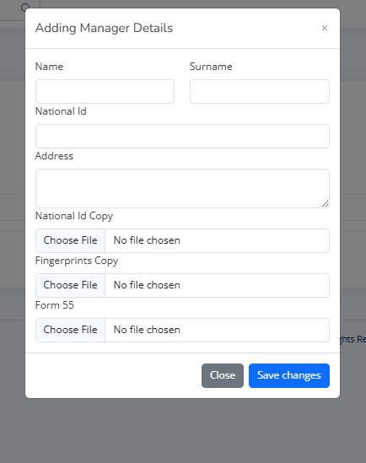

* **Manager Details:** Fill in the manager's name, National ID, and address.
* **Upload Documents:** Upload copies of the manager's National ID, fingerprints, and Form 55.
* **Save:** Click "Save Changes" to add the manager.
* **Cancel:** Click "Close" to exit without saving.

**Important:** Ensure all details and documents are accurate.

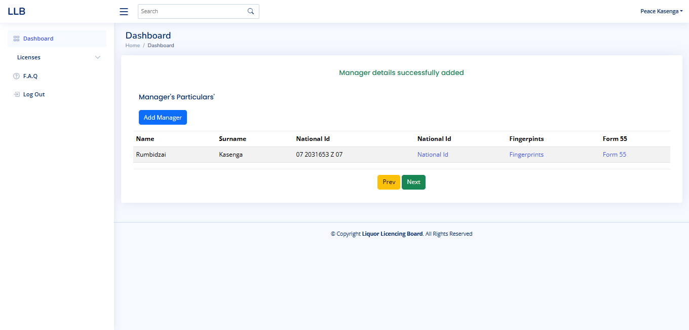

After adding a manager, their details will appear in the table under "Manager's Particulars," confirming that the information has been successfully added.

You can review the manager's name, surname, National ID, and uploaded documents. If you need to add more managers, click the "Add Manager" button again. Once you have finished adding all manager information, click the "Next" button to proceed, or click "Prev" to go back to the previous step.

Ensure all details are accurate before moving forward.

#### 2.10 Uploading Required Attachments

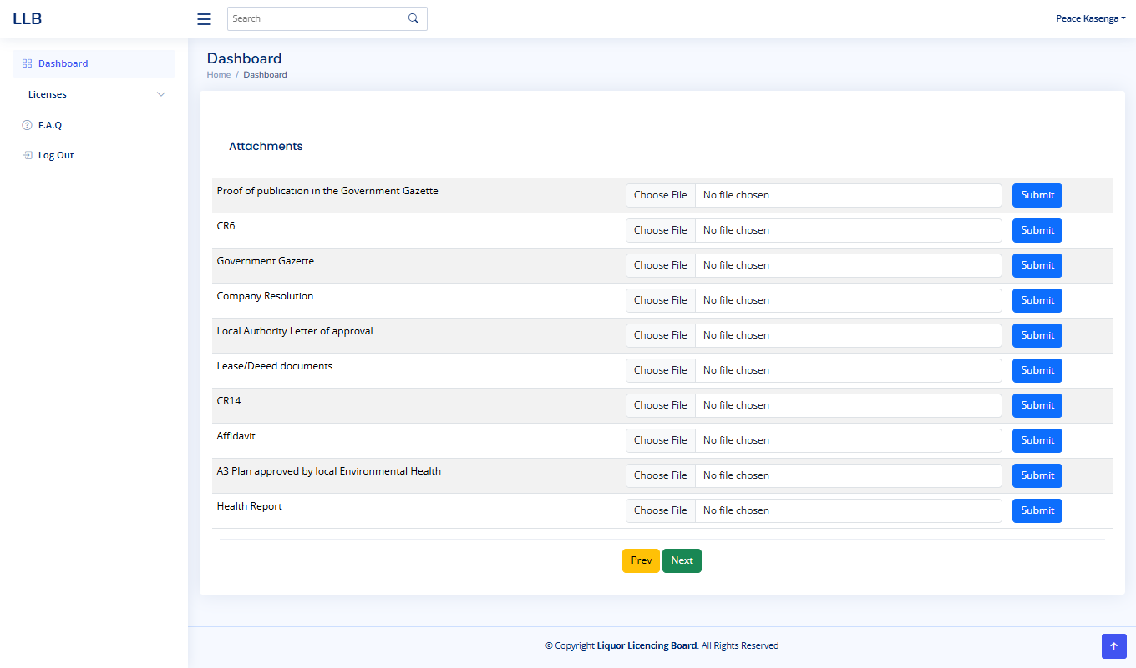

This page requires you to upload specific documents for your liquor license application.

* **Company Applicants:** Upload all listed documents, including Proof of Publication, CR6, Government Gazette, Company Resolution, Local Authority Approval, Lease/Deed, CR14, Affidavit, A3 Plan, and Health Report.
* **Organization Applicants:** Upload all listed documents, including your organization's constitution, Proof of Publication, Government Gazette, Local Authority Approval, Lease/Deed, Affidavit, A3 Plan, and Health Report.
* **Individual Applicants:** Upload Proof of Publication, Government Gazette, Local Authority Approval, Lease/Deed, Affidavit, A3 Plan, and Health Report.

Use the "Choose File" button to select each document, then **immediately click "Submit"** next to that document. Repeat this process for each document listed. Ensure all documents are clear and legible. Click "Prev" to go back or "Next" to continue.

#### Managing Uploaded Attachments

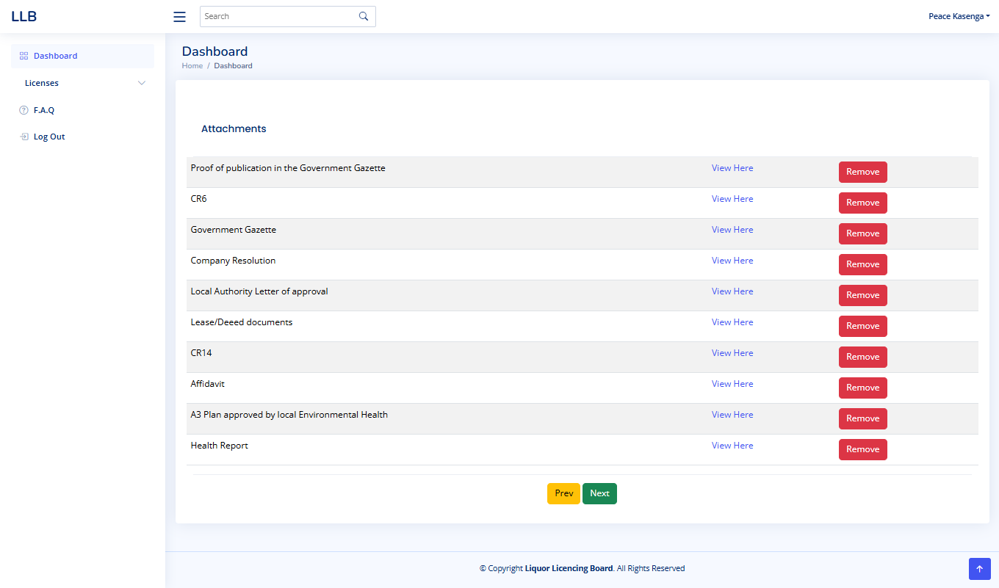

This page displays the documents you have uploaded for your liquor license application.

* **View Documents:** To view a document, click the "View Here" link next to it.
* **Remove Documents:** To remove an uploaded document, click the "Remove" button next to it.

Ensure all listed documents are correct before proceeding by clicking "Next". Use "Prev" to go back to the previous step.

#### 2.11 Finalizing Your Application and Payment

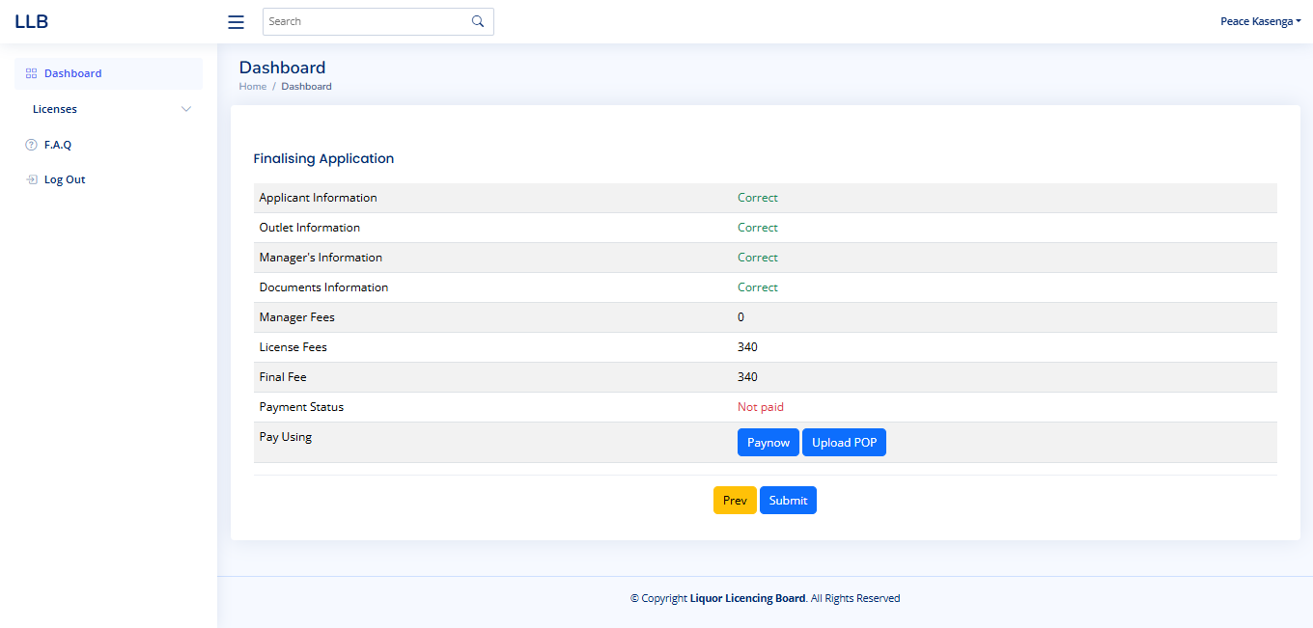

This page summarizes your application details and payment information.

* **Review Details:** Confirm that the "Applicant Information," "Outlet Information," "Manager's Information," and "Documents Information" are marked as "Correct."
* **Fees:** Review the "Manager Fees," "License Fees," and "Final Fee" amounts.
* **Payment Status:** The "Payment Status" will show "Not paid" until payment is received.
* **Payment Options:**
  + **Paynow:** Click the "Paynow" button to pay online.
  + **Upload POP:** If you paid manually (e.g., bank transfer), click "Upload POP" to upload your Proof of Payment.
* **Submit:** After payment is processed or the Proof of Payment is uploaded, click "Submit" to finalize your application.
* **Previous:** Click "Prev" to return to the previous step.

**Important:** Ensure all information is accurate before submitting.

#### Uploading Proof of Payment (Manual Payment)

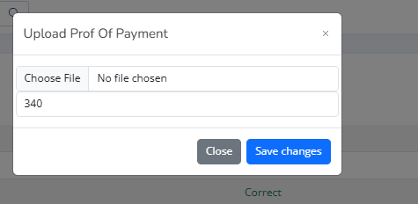

If you paid your liquor license fees manually (e.g., through a bank transfer), you will need to upload your Proof of Payment (POP).

* **Upload POP:** Click the "Upload POP" button.
* **Select File:** In the pop-up window, click "Choose File" to select the digital copy of your Proof of Payment from your device.
* **Verify Amount:** Confirm that the amount displayed matches the payment you made.
* **Save:** Click "Save changes" to upload the Proof of Payment.
* **Close:** If you need to cancel the upload, click "Close."

**Important:** Ensure the Proof of Payment is clear and shows the correct amount paid.

#### Paying with Paynow

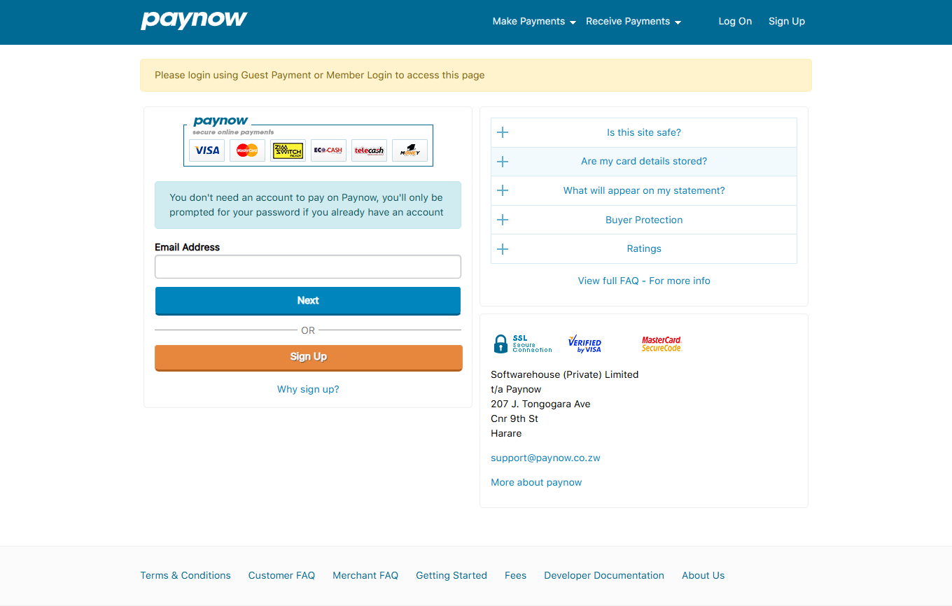

Paynow is a secure online payment gateway that allows you to pay your liquor license fees directly from your computer or mobile device. Here's how it works:

1. **Click "Paynow":** On the application summary page, click the "Paynow" button. You will be redirected to the Paynow website.
2. **Guest or Member Login:** You can either log in with your Paynow account (if you have one) or proceed as a guest.
3. **Enter Email:** Provide a valid email address where you will receive your payment confirmation.
4. **Click "Next":** Proceed to the payment details page.
5. **Select Payment Method:** Choose your preferred payment method (e.g., Visa, Mastercard, Ecocash, OneMoney).
6. **Enter Payment Details:** Enter your card or mobile money details as required.
7. **Confirm Payment:** Review the payment details and confirm the transaction.
8. **Payment Confirmation:** You will receive a confirmation message on the screen and via email.
9. **Return to Application:** Once the payment is successful, you will be redirected back to the liquor license application system.
10. **Application Status Update:** Your payment status will be updated to "Paid."

**Important:** Paynow is a secure and reliable payment gateway. If you encounter any issues during the payment process, please contact Paynow support directly.

#### Application Verification Process (Following Payment)

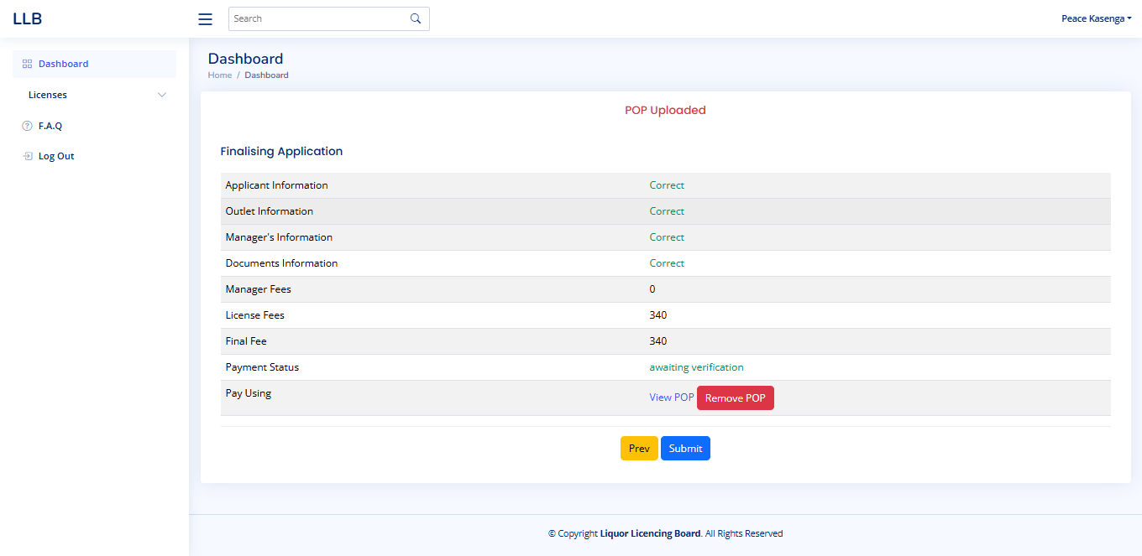

This page shows the status of your application after you have submitted your payment, either through Paynow or by uploading your Proof of Payment (POP).

**Key Elements:**

* **"POP Uploaded" Message:** This message at the top indicates that you have successfully uploaded your Proof of Payment, if you paid manually.
* **Application Summary:** The "Finalising Application" section provides a summary of your application details:
  + **Applicant Information, Outlet Information, Manager's Information, Documents Information:** These all show "Correct," indicating that you have completed these sections.
  + **Manager Fees, License Fees, Final Fee:** These show the fee amounts.
  + **Payment Status:** This shows "awaiting verification." This means that your payment is being processed.
* **Pay Using:**
  + **View POP:** If you uploaded a POP, you can click this to view it.
  + **Remove POP:** If you need to remove and re-upload the POP, you can use this button.
* **Navigation:**
  + **Prev:** Click this to go back to the previous step.
  + **Submit:** This button is still present, but it will likely be disabled until the payment verification is complete.

**Verification Process:**

* **Paynow Payments:** If you paid via Paynow, your application goes directly to the verifier.
* **Manual Payments (POP Upload):** If you uploaded a POP, the accountant verifies the payment first, then it goes to the verifier.

**Important Notes:**

* **Verification Time:** Be patient, as verification can take some time.
* **Accuracy:** Ensure all details were correct to avoid delays.
* **Contact:** If you have questions, contact the Liquor Licensing Board.

#### 2.12 Tracking Your Application After Submission

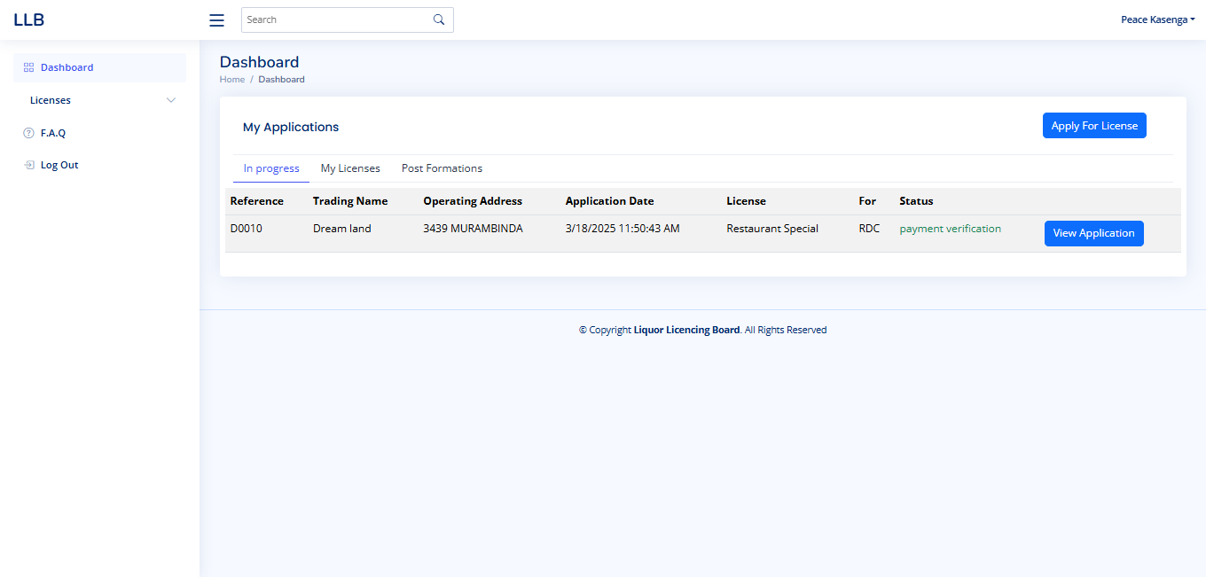

Once you have submitted your liquor license application and completed the payment process, you can track its progress on the Dashboard.

**Key Elements:**

* **"My Applications" Table:** This table displays your submitted applications.
  + **Reference:** A unique reference number (e.g., D0010) assigned to your application.
  + **Trading Name:** The name of your business (e.g., Dream land).
  + **Operating Address:** The address of your business (e.g., 3439 MURAMBINDA).
  + **Application Date:** The date and time you submitted the application.
  + **License:** The type of license applied for (e.g., Restaurant Special).
  + **For:** Additional information about the license (e.g., RDC).
  + **Status:** The current status of your application (e.g., "payment verification").
  + **View Application:** Click this button to view the details of your application.
* **"In progress" Tab:** Ensure the "In progress" tab is selected to view submitted applications that are under review.

**Application Status:**

* The "Status" column will show the current stage of your application, such as "payment verification" in this example.
* The status will change as your application progresses through the verification and approval process.

**Important Notes:**

* Regularly check the Dashboard to monitor the status of your application.
* If you have any questions or concerns, contact the Liquor Licensing Board.

#### 2.13 Accessing Your Approved Licenses

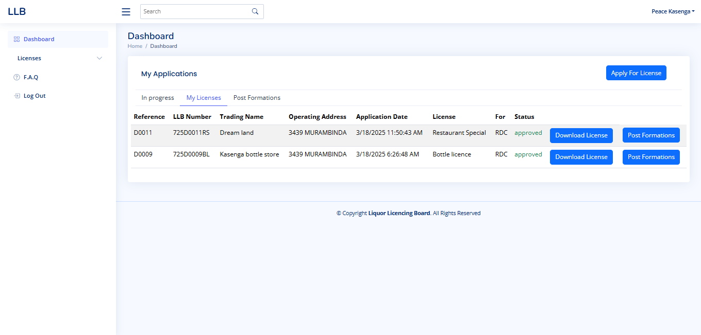

After your liquor license application has been verified, recommended, and approved, you can access and download your license from the "My Licenses" tab on the Dashboard.

**Key Features:**

* **"My Licenses" Tab:** Click this tab to view your approved licenses.
* **License List:**
  + Displays a list of your approved licenses.
  + Columns include:
    - **Reference:** A unique reference number for each license.
    - **LLB Number:** The official Liquor Licensing Board number.
    - **Trading Name:** The name of your business.
    - **Operating Address:** The address of your business.
    - **Application Date:** The date the application was submitted.
    - **License:** The type of license (e.g., Restaurant Special, Bottle license).
    - **For:** Additional licensing information (e.g., RDC).
    - **Status:** "Approved" indicates the license is ready for download.
    - **Download License:** Click this button to download a digital copy of your approved license.
    - **Post Formations:** Click this button to make any changes or updates to your license after it has been issued.
* **"Apply For License" Button:** This button remains available if you wish to apply for a new license.

**Using the Page:**

* **Download License:** Click "Download License" to save a copy of your license to your device.
* **Post Formations:** If you need to make changes to your license details (e.g., address change), click "Post Formations".

**Important Notes:**

* **License Validity:** Ensure you understand the validity period and renewal requirements of your license.
* **Display License:** Display your downloaded license prominently at your business premises.
* **Post Formations:** Keep your license information up-to-date by using the "Post Formations" feature when necessary.
* **Contact:** If you have any questions or need assistance, contact the Liquor Licensing Board.

# Accountant

#### 3.1 Accountant Dashboard Overview

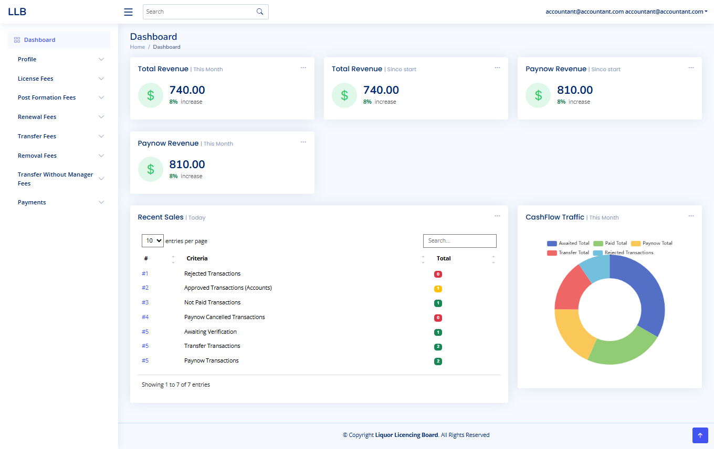

This is the main screen for the accountant in the Liquor Licensing Board (LLB) system. It provides a quick look at financial transactions and application statuses.

**Key Information:**

* **Revenue:** You'll see "Total Revenue" for the month and since the start, plus "Paynow Revenue." These show the money coming in, with percentage increases.
* **Paynow Revenue:** This shows just the revenue from Paynow payments for the month.
* **Recent Activity:** "Recent Sales Today" lists the day's transactions, like approved or rejected applications, and payments.
* **Cash Flow:** The pie chart shows how different types of transactions contribute to the overall cash flow.
* **Navigation:** Use the menu on the left to access specific financial reports and transaction details.
* **Search:** Use the search bar to find specific transactions.
* **User Info:** Your logged-in email is shown at the top right.

**Using the Dashboard:**

* Review the revenue and cash flow to understand the financial health of the LLB.
* Check recent activity to monitor transactions.
* Use the left menu to access detailed financial reports.
* Use the search bar to find transactions.

**Important:** Make sure to regularly check the financial data for accuracy.

#### 3.2 Changing Your Password

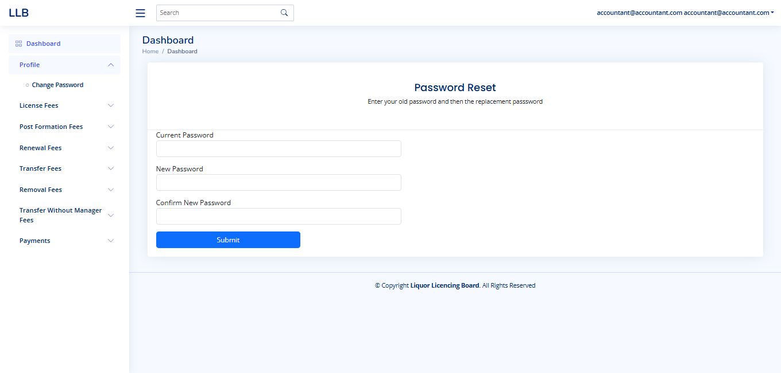

This page allows you to change your password for the Liquor Licensing Board (LLB) system.

**Steps:**

1. **Enter Current Password:** In the "Current Password" field, type your existing password.
2. **Enter New Password:** In the "New Password" field, type the new password you wish to use.
3. **Confirm New Password:** In the "Confirm New Password" field, re-type the new password exactly as you entered it in the previous step.
4. **Submit:** Click the "Submit" button to save your new password.

**Important Notes:**

* **Password Security:** Choose a strong password that is difficult to guess. It should include a combination of uppercase and lowercase letters, numbers, and symbols.
* **Confirmation:** Make sure the "New Password" and "Confirm New Password" fields match exactly.
* **Remember Your Password:** After changing your password, make sure to remember it or store it in a secure location.
* **Contact Support:** If you encounter any issues changing your password, contact the system administrator or support team.

#### 3.3 Managing Payments

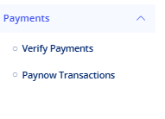

The "Payments" section in the left navigation menu allows the accountant to manage and verify payments related to liquor license applications.

* **Verify Payments:** This option is used to review and approve payments made manually (e.g., bank transfers) by applicants. The accountant will check the uploaded Proof of Payment (POP) against the application details and confirm the payment.
* **Paynow Transactions:** This option provides a list of all transactions made through the Paynow payment gateway. The accountant can view details of each Paynow transaction, including the applicant's details, payment amount, and transaction status.

This section ensures that all payments, whether manual or online, are accurately recorded and verified before an application can proceed to the next stage.

#### 3.4 Verifying Manual Payments

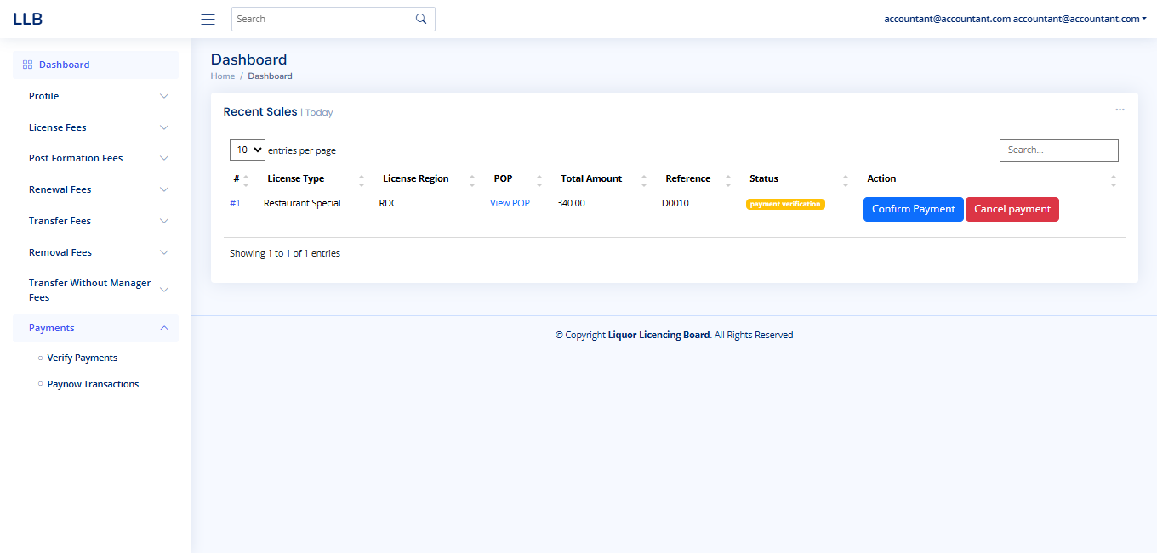

This page allows the accountant to verify payments made manually by applicants for their liquor license applications.

**Key Features:**

* **Recent Sales Table:**
  + Displays a list of manual payment transactions.
  + **License Type:** Shows the type of license applied for (e.g., Restaurant Special).
  + **License Region:** Indicates the region the license pertains to (e.g., RDC).
  + **POP:** Provides a link ("View POP") to view the applicant's uploaded Proof of Payment.
  + **Total Amount:** Shows the amount paid.
  + **Reference:** Displays the application reference number.
  + **Status:** Shows the current status of the payment (e.g., "payment verification").
  + **Action:** Offers two options:
    - **Confirm Payment:** Click this to approve the payment after verifying the POP.
    - **Cancel Payment:** Click this to reject the payment if the POP is invalid or the payment is incorrect.
* **Search:** Use the search bar to find specific payment transactions.
* **Entries Per Page:** Adjust the number of entries displayed per page using the dropdown.

**Verification Process:**

1. **View POP:** Click "View POP" to review the applicant's Proof of Payment.
2. **Verify Details:** Check the payment amount and details against the application information.
3. **Confirm or Cancel:**
   * If the payment is correct, click "Confirm Payment."
   * If the payment is incorrect or the POP is invalid, click "Cancel Payment."

**Important:**

* Ensure you carefully verify the Proof of Payment before confirming any payment.
* If you cancel a payment, provide a clear reason to the applicant.

# VERIFIER

#### 4.1 Verifier Dashboard Overview

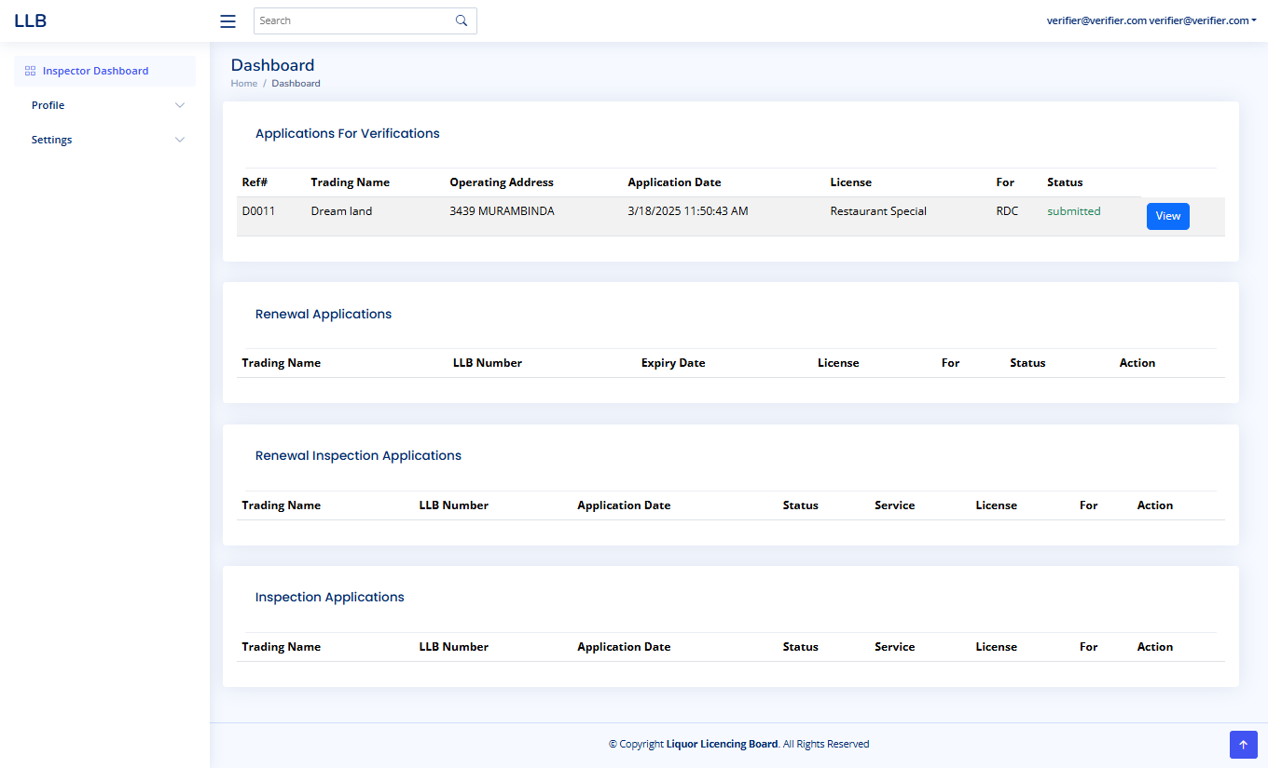

This is the main dashboard for the verifier in the Liquor Licensing Board (LLB) system. It provides a summary of applications requiring verification and other related tasks.

**Key Features:**

* **Applications For Verifications:**
  + Displays a list of new applications submitted for verification.
  + Columns include:
    - **Ref #:** Application reference number.
    - **Trading Name:** Name of the business.
    - **Operating Address:** Address of the business.
    - **Application Date:** Date and time of application submission.
    - **License:** Type of license applied for.
    - **For:** Additional licensing information.
    - **Status:** Current status of the application (e.g., "submitted").
    - **View:** Button to view the application details.
* **Renewal Applications:**
  + Lists applications for license renewals.
* **Renewal Inspection Applications:**
  + Lists renewal applications requiring inspections.
* **Inspection Applications:**
  + Lists new applications requiring inspections.
* **Left Navigation Menu:**
  + **Profile:** Access and manage verifier profile.
  + **Settings:** Access system settings.
* **User Information:**
  + The verifier's email is displayed at the top right.
* **Search Functionality:**
  + Search bar for finding specific applications.

**Using the Dashboard:**

To start verifying an application, click the "View" button in the "Applications For Verifications" table.

* Review the "Applications For Verifications" table to begin verifying new applications.
* Use the other tables to manage renewal and inspection tasks.
* Use the left navigation menu to access profile and settings.
* Use search bar to find specific application.

**Important Notes:**

* Regularly check the dashboard for new applications.
* Ensure all verifications are completed accurately and in a timely manner.

#### 4.1 Verifying Applicant Information and Raising Queries

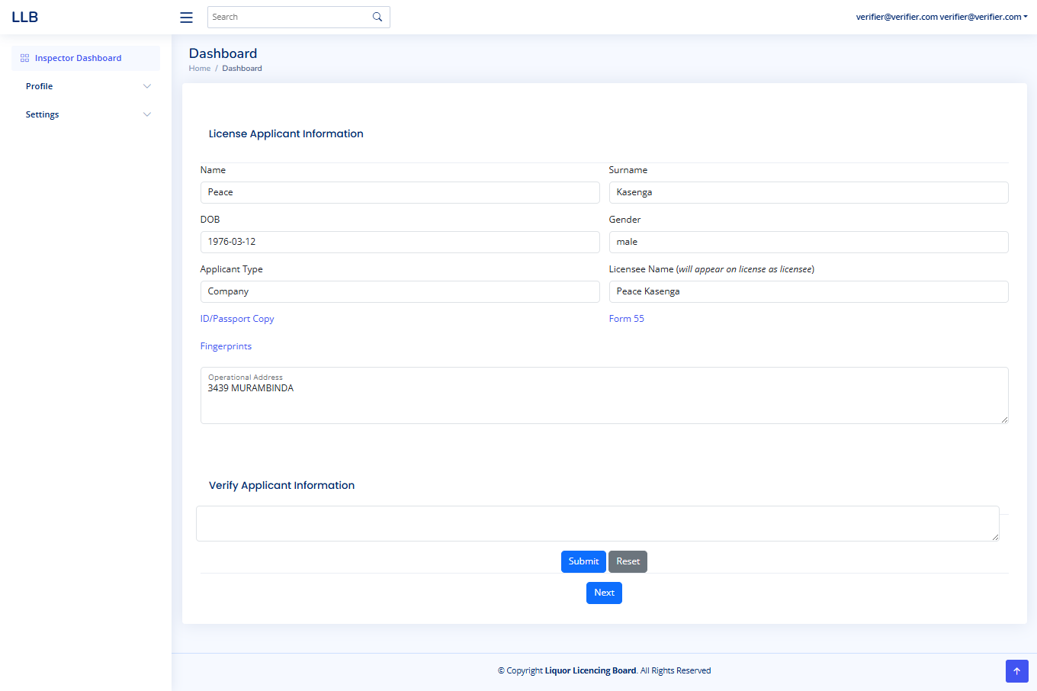

This page allows the verifier to review the applicant's information and raise queries if necessary.

**Key Features:**

* **License Applicant Information:** Displays the applicant's details, including name, date of birth, gender, applicant type, licensee name, uploaded documents (ID/Passport Copy, Fingerprints, Form 55), and operational address.
* **Verify Applicant Information:** This section is where the verifier can raise queries or provide feedback.
  + **Query Field:** Enter your query or feedback in the text box.
  + **Submit:** Click "Submit" to send the query back to the applicant.
  + **Reset:** Click "Reset" to clear the query field.
* **Next:** If the information is correct and no queries are needed, click "Next" to proceed.

**Verification Process:**

1. **Review Information:** Carefully review all the applicant's details and uploaded documents.
2. **Raise Query (If Needed):**
   * If you find any discrepancies or need additional information, type your query in the "Verify Applicant Information" field.
   * Click "Submit" to send the query back to the applicant. The application will be returned to the applicant for resolution.
3. **Approve Information (If Correct):**
   * If all information is correct, click "Next" to proceed to the next stage of verification.

**Important Notes:**

* **Clarity:** Ensure your queries are clear and specific.
* **Applicant Communication:** The applicant will be notified of the query and will need to address it before the application can proceed.
* **Timeliness:** Complete verifications and raise queries in a timely manner.

#### 4.3 Application Verification and Approval

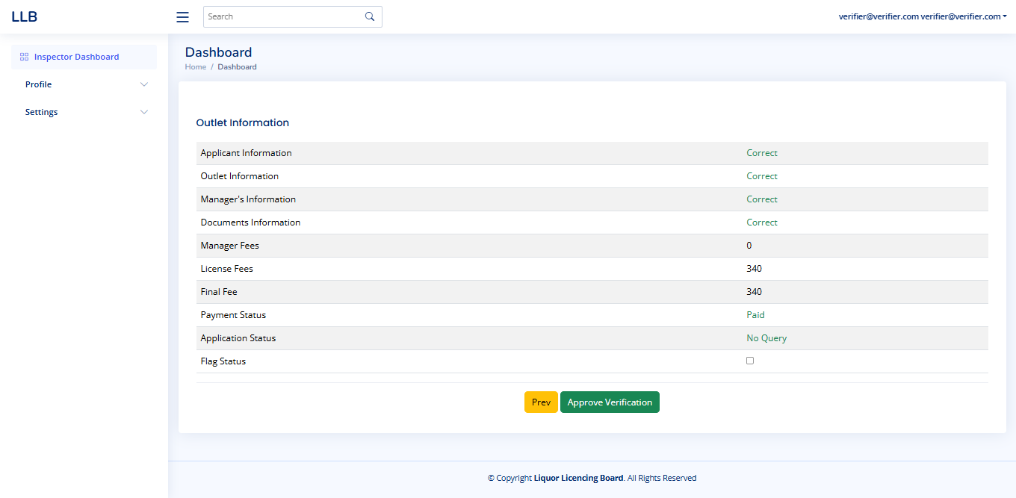

This page displays the status of the application after verification.

* **Application Details:** The page summarizes key application details, including Applicant Information, Outlet Information, Manager's Information, Documents Information, Fees, Payment Status, and Application Status.
* **Application Status:**
  + **"No Query" Status:** If the "Application Status" shows "No Query," it means the verifier found no issues during verification. In this case, click "Approve Verification" to approve the application.
  + **Query Status:** If the verifier encountered any issues, the application would have been sent back to the applicant for resolution.
* **Approval:** Once the application has "No Query" status, click "Approve Verification" to finalize the verification process.
* **Previous:** Click "Prev" to review the previous verification steps.

**Important:** Ensure all details are correct before approving the application.

**This process of reviewing information and raising queries will apply to each subsequent step of the verification process until the application is finalized.**

# Recommender

#### 5.1 Recommender Dashboard Overview

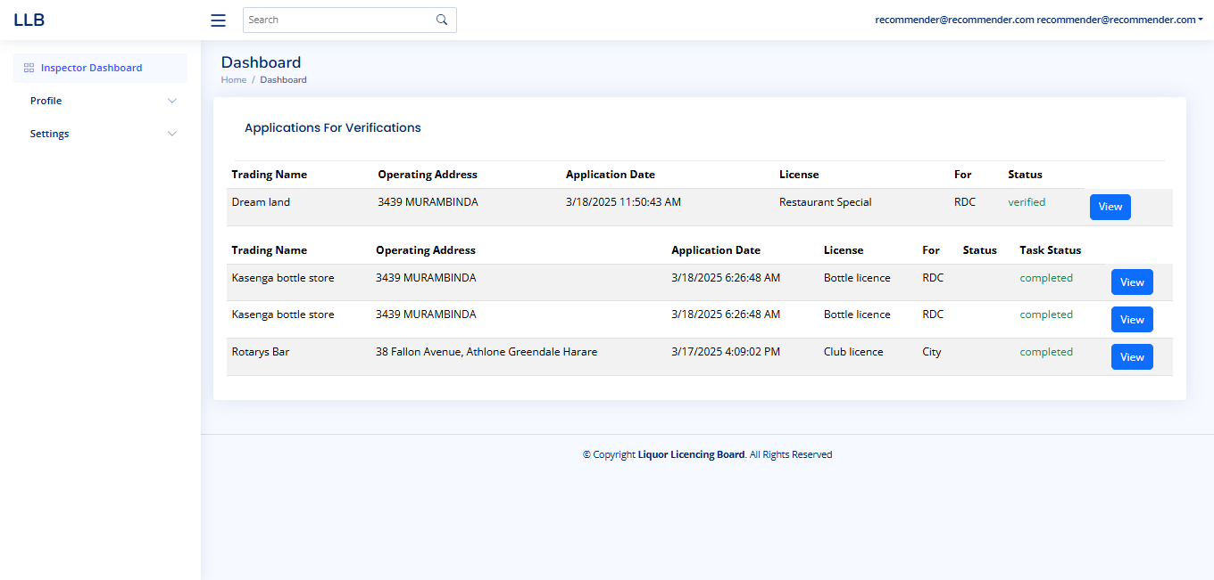

This is the main dashboard for the recommender in the Liquor Licensing Board (LLB) system. It displays applications that have been verified by the verifier and are now ready for the recommender's review.

**Key Features:**

* **Applications For Verifications:**
  + Lists applications that have been verified and are awaiting the recommender's decision.
  + Columns include:
    - **Trading Name:** Name of the business.
    - **Operating Address:** Address of the business.
    - **Application Date:** Date and time of application submission.
    - **License:** Type of license applied for.
    - **For:** Additional licensing information.
    - **Status:** Current status of the application (e.g., "verified").
    - **View:** Button to view the application details and begin the recommendation process.
* **Completed Applications:**
  + Displays applications that have been processed and completed.
  + Columns include:
    - **Trading Name:** Name of the business.
    - **Operating Address:** Address of the business.
    - **Application Date:** Date and time of application submission.
    - **License:** Type of license applied for.
    - **For:** Additional licensing information.
    - **Task Status:** Status of the completed task (e.g., "completed").
    - **View:** Button to view the completed application details.
* **Left Navigation Menu:**
  + **Profile:** Access and manage recommender profile.
  + **Settings:** Access system settings.
* **User Information:**
  + The recommender's email is displayed at the top right.
* **Search Functionality:**
  + Search bar for finding specific applications.

**Using the Dashboard:**

* **To start reviewing a verified application, click the "View" button in the "Applications For Verifications" table.**
* Review completed applications in the "Completed Applications" section.
* Use the left navigation menu to access profile and settings.
* Use search bar to find specific applications.

**Important Notes:**

* Regularly check the dashboard for new applications.
* Ensure all recommendations are made accurately and based on the verification details.
* **Clicking "View" is the first step to begin the recommendation process.**

#### 5.2 Recommending Applicant Information and Raising Queries

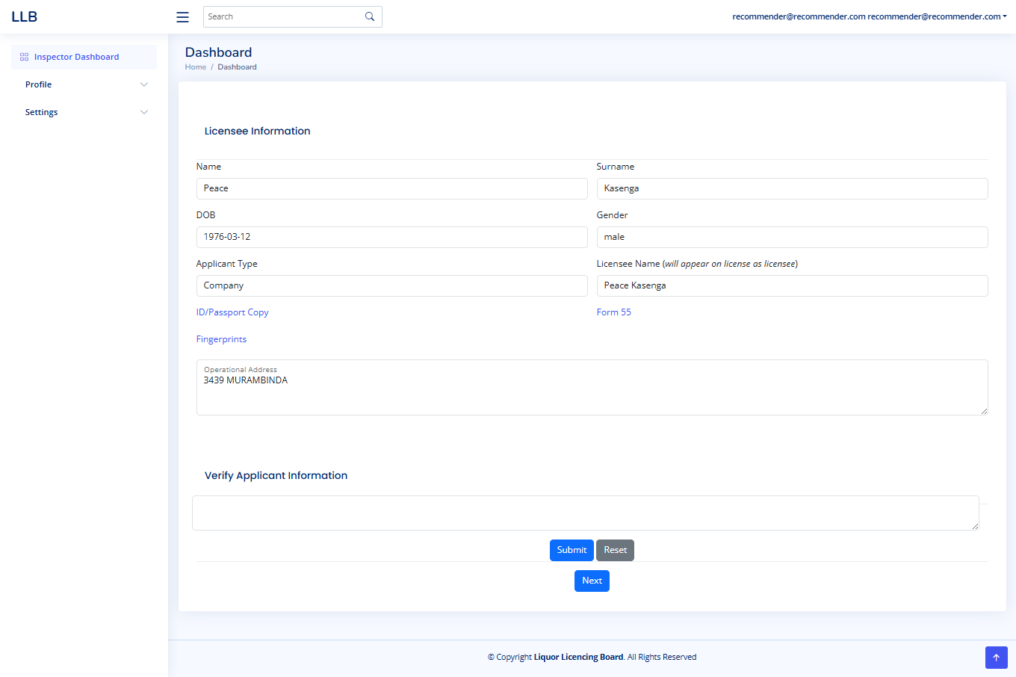

This page allows the recommender to review the applicant's information after it has been verified and to raise queries if necessary.

**Key Features:**

* **Licensee Information:** Displays the applicant's details, including name, date of birth, gender, applicant type, licensee name, uploaded documents (ID/Passport Copy, Fingerprints, Form 55), and operational address.
* **Verify Applicant Information:** This section is where the recommender can raise queries or provide feedback.
  + **Query Field:** Enter your query or feedback in the text box.
  + **Submit:** Click "Submit" to send the query back to the applicant.
  + **Reset:** Click "Reset" to clear the query field.
* **Next:** If the information is correct and no queries are needed, click "Next" to proceed.

**Recommendation Process:**

1. **Review Information:** Carefully review all the applicant's details and uploaded documents, which have already been verified by the verifier.
2. **Raise Query (If Needed):**
   * If you find any discrepancies or need additional information, type your query in the "Verify Applicant Information" field.
   * Click "Submit" to send the query back to the applicant for resolution. The application will be returned to the applicant.
3. **Approve Information (If Correct):**
   * If all information is correct, click "Next" to proceed to the next stage of the recommendation process.

**Important Notes:**

* **Clarity:** Ensure your queries are clear and specific.
* **Applicant Communication:** The applicant will be notified of the query and will need to address it before the application can proceed.
* **Timeliness:** Complete recommendations and raise queries in a timely manner.
* **This process of reviewing information and raising queries will apply to each subsequent step of the recommendation process until the application is finalized.**

#### 5.3 Recommending Application Approval

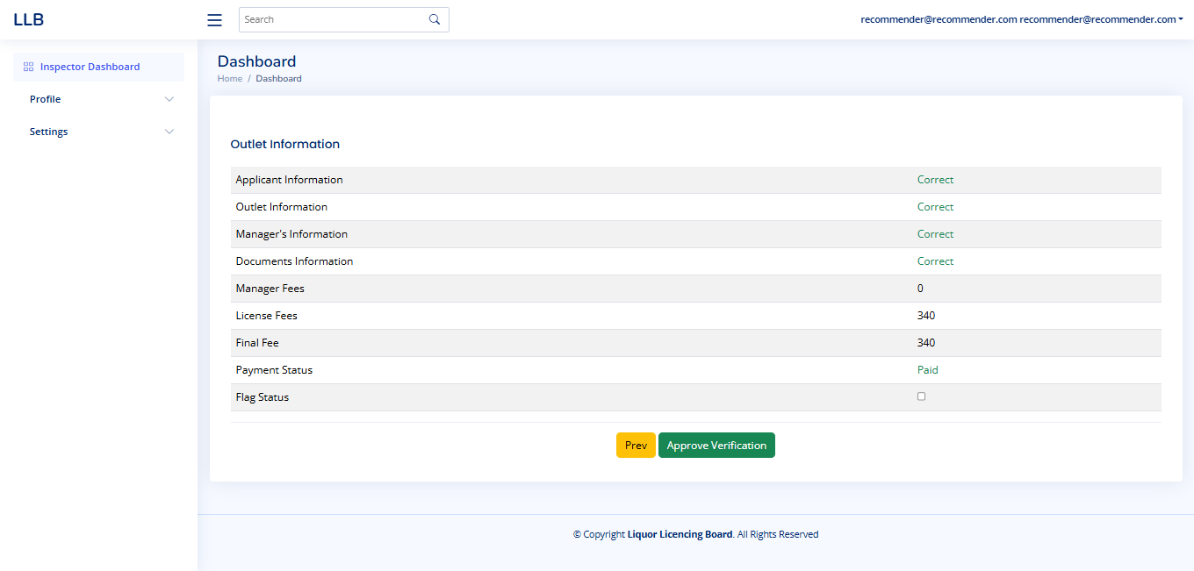

This page displays the application summary after the recommender has reviewed all the verified information.

* **Application Details:** The page summarizes key application details, including Applicant Information, Outlet Information, Manager's Information, Documents Information, Fees, Payment Status, and Flag Status.
* **Approval:** If the recommender finds all the verified information to be correct and in order, they can click the "Approve Verification" button to recommend the application for final approval.
* **Previous:** The "Prev" button allows the recommender to go back and review the previous verification steps if needed.

**Important Notes:**

* **Final Recommendation:** This is the recommender's final step in the application process. Ensure all details have been thoroughly reviewed before approving.
* **Accuracy:** Double-check all information before clicking "Approve Verification."
* **Flag Status:** The "Flag Status" being empty means no flags were raised during the verification process.

# Secretary

#### 6.1 Secretary Dashboard Overview

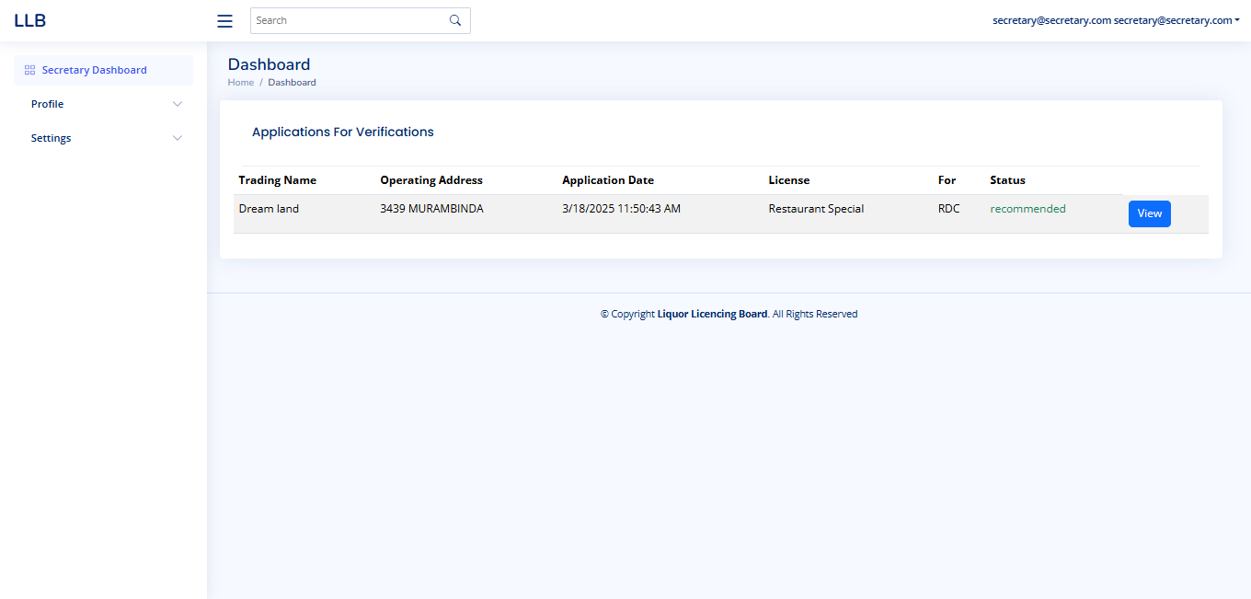

This is the main dashboard for the secretary in the Liquor Licensing Board (LLB) system. It displays applications that have been recommended by the recommender and are now awaiting the secretary's final approval.

**Key Features:**

* **Applications For Verifications:**
  + Lists applications that have been recommended and are awaiting the secretary's decision.
  + Columns include:
    - **Trading Name:** Name of the business.
    - **Operating Address:** Address of the business.
    - **Application Date:** Date and time of application submission.
    - **License:** Type of license applied for.
    - **For:** Additional licensing information.
    - **Status:** Current status of the application (e.g., "recommended").
    - **View:** Button to view the application details and begin the final approval process.
* **Left Navigation Menu:**
  + **Profile:** Access and manage secretary profile.
  + **Settings:** Access system settings.
* **User Information:**
  + The secretary's email is displayed at the top right.
* **Search Functionality:**
  + Search bar for finding specific applications.

**Using the Dashboard:**

* **To start reviewing a recommended application, click the "View" button in the "Applications For Verifications" table.**
* Use the left navigation menu to access profile and settings.
* Use search bar to find specific applications.

**Important Notes:**

* Regularly check the dashboard for new applications.
* Ensure all applications are thoroughly reviewed before final approval.
* **Clicking "View" is the first step to begin the final approval process.**

#### 6.2 Managing License Types

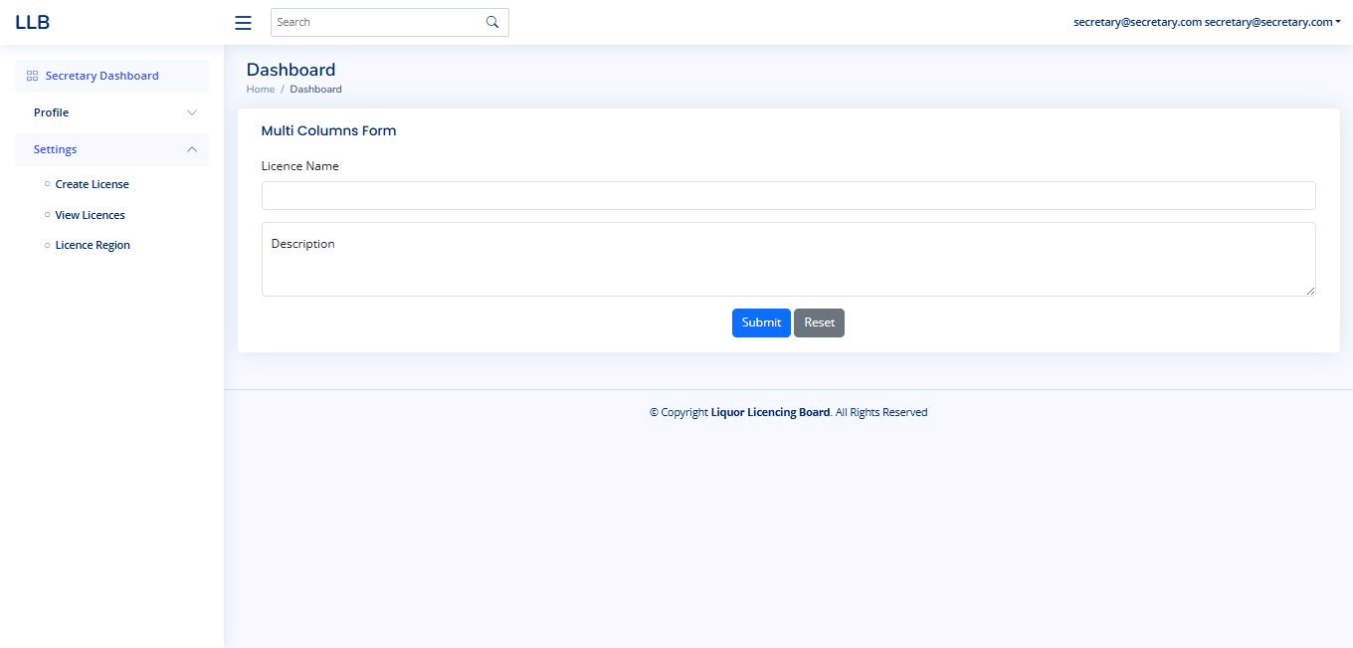

This is the main dashboard for the secretary in the Liquor Licensing Board (LLB) system. It serves two primary functions: managing license types and approving recommended applications.

**Key Features:**

* **Image 1: Managing License Types**
  + **Multi Columns Form:** This section allows the secretary to create new license types and define license regions.
  + **Licence Name:** Enter the name of the new license type.
  + **Licence Region:** Enter the region where this license type applies.
  + **Description:** Provide a description of the license type.
  + **Submit/Reset:** Use these buttons to save or clear the form.
  + **Left Navigation:** The left menu provides access to "Create License," "View Licences," and "Licence Region" management.

#### 6.3 Managing License Types and Conditions

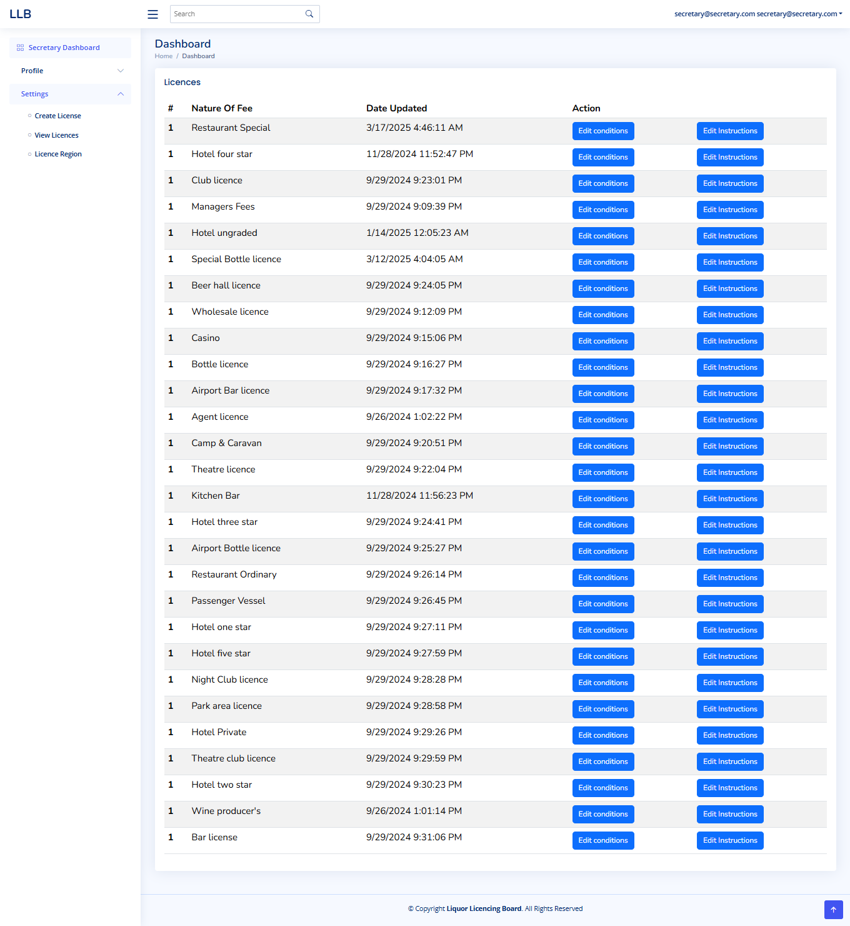

This page allows the secretary to manage and configure various license types within the Liquor Licensing Board (LLB) system, **Key Features:**

* **License List:**
  + Displays a comprehensive list of all license types available in the system.
  + **#:** A sequential number for each license type.
  + **Nature Of Fee:** The name of the license type (e.g., "Restaurant Special," "Hotel four star").
  + **Date Updated:** The date and time when the license type was last modified.
  + **Action:** Provides two options for each license type:
    - **Edit Conditions:** Allows the secretary to modify the specific conditions and requirements for issuing that particular license.
    - **Edit Instructions:** Allows the secretary to modify the instructions and guidelines provided to applicants for that license type.
* **Left Navigation Menu:**
  + **Create License:** Navigate to the page for creating new license types.
  + **View Licences:** This is the current page, displaying the list of licenses.
  + **Licence Region:** Navigate to the page for managing license regions.
* **User Information:**
  + The secretary's email is displayed at the top right.
* **Search Functionality:**
  + A search bar is available for finding specific license types.

**Using the Page:**

* **View License Details:** Review the list of license types and their last update dates.
* **Edit Conditions:** Click "Edit Conditions" to modify the specific requirements and regulations for a particular license.
* **Edit Instructions:** Click "Edit Instructions" to modify the guidelines and instructions provided to applicants.
* **Create New License:** Use the "Create License" option in the left menu to add a new license type to the system.

**Important Notes**

**Local Regulations:** Ensure all license conditions and instructions comply with the specific regulations and requirements of **Accuracy:** Double-check all changes before saving to avoid errors.

* **Consistency:** Maintain consistency in the conditions and instructions across different license types.
* **Contact:** If you have questions about local regulations, contact the Liquor Licensing Board.

#### 6.4 Managing License Regions

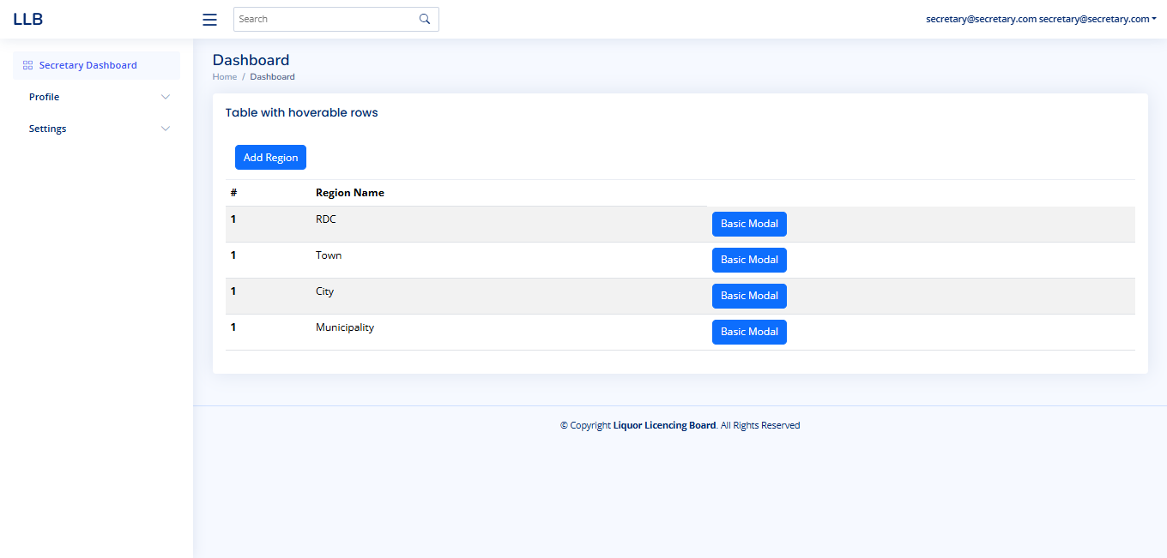

This page allows the secretary to manage and define the various regions within the Liquor Licensing Board (LLB) system.

**Key Features:**

* **Region List:**
  + Displays a list of defined license regions.
  + **#:** A sequential number for each region.
  + **Region Name:** The name of the region (e.g., "RDC," "Town," "City," "Municipality").
  + **Basic Modal:** A button that likely opens a modal window to view or edit the details of the specific region.
* **Add Region Button:**
  + Allows the secretary to add new license regions to the system.
* **Left Navigation Menu:**
  + **Profile:** Access and manage secretary profile.
  + **Settings:** Access system settings.
* **User Information:**
  + The secretary's email is displayed at the top right.
* **Search Functionality:**
  + A search bar is available for finding specific regions.

**Using the Page:**

* **View Region Details:** Review the list of defined license regions.
* **Add New Region:** Click the "Add Region" button to create a new region.
* **Edit Region Details:** Click the "Basic Modal" button to view or modify the details of a specific region.

**Important Notes:**

* **Accuracy:** Double-check all changes before saving to avoid errors.
* **Consistency:** Maintain consistency in the region definitions.
* **Contact:** If you have questions about region definitions, contact the relevant authorities.

#### 6.5 Final Application Approval or Rejection

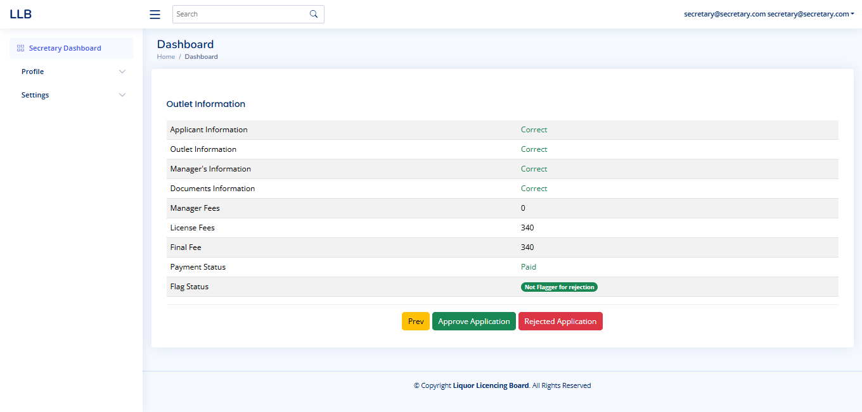

This page allows the secretary to make the final decision on a liquor license application after it has been recommended.

**Key Features:**

* **Application Summary:**
  + Displays a summary of the application, including:
    - Applicant Information
    - Outlet Information
    - Manager's Information
    - Documents Information
    - Fees
    - Payment Status
    - Flag Status
* **Flag Status:**
  + Indicates whether the application has been flagged for rejection. In this case, it shows "Not Flagged for rejection."
* **Action Buttons:**
  + **Approve Application:** Click this button to approve the application and issue the license.
  + **Rejected Application:** Click this button to reject the application.
  + **Prev:** Click this button to go back to the previous step.
* **User Information:**
  + The secretary's email is displayed at the top right.

**Using the Page:**

* **Review Summary:** Carefully review all the information displayed in the application summary.
* **Make Decision:**
  + If all information is correct and the application meets the requirements, click "Approve Application."
  + If there are issues or the application does not meet the requirements, click "Rejected Application."

**Important Notes:**

* **Final Decision:** The secretary's decision is final.
* **Accuracy:** Ensure all information is accurate before approving or rejecting the application.
* **Rejection Reasons:** If rejecting an application, provide clear reasons to the applicant.

# USER – ADMIN

#### 7.1 User Login

To log in to the LLB administration portal one needs to visit the link [Liquor Licencing Board - LLB](https://llb.pfms.gov.zw/Auth/Login) when connected to the LLB network. The link will take you to the login page, where you key in the registered email for user name and set password and click sign in.

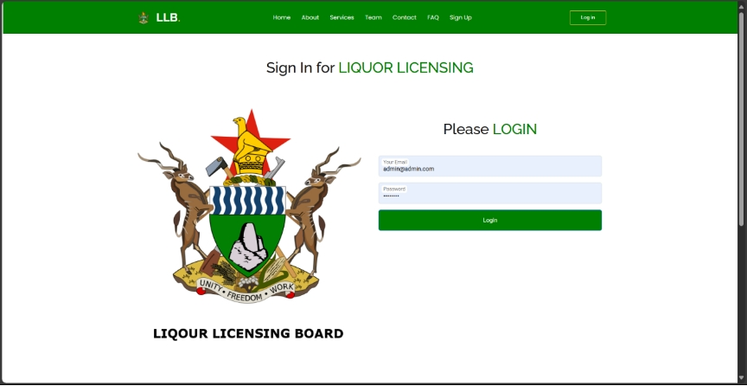

Solution validates provided details, if password or username is correct, if not, system prompts user to recapture their details and rerun the process. If one has forgotten their password, they use the “Forgot password” option to create a new password. The system requests one to provide their registered email in order for it to generate and send a link that can be used to setup a new password.

#### 

#### 7.2 Limited Troubleshooting Steps for Common Login Issues

##### 1. Incorrect Username or Password:

Double-check your username and password for typos.Ensure you're entering the correct credentials for the specific account.If you've forgotten your password, use the password reset option or contact your system administrator.

##### 2. Browser Compatibility:

Try a Different Browser: Test the login process with a different browser (e.g., Chrome, Firefox, Edge).Clear Browser Cache and Cookies: Clear your browser's cache and cookies, as outdated data can sometimes interfere with the login process.Disable Browser Extensions: Temporarily disable browser extensions that might be interfering with the login process.Check Browser Compatibility: Ensure your browser version is compatible with the system's requirements.

##### 3. Network Connectivity Issues:

Check Internet Connection: Verify that you have a stable internet connection.Firewall and Proxy Settings: Ensure that your firewall and proxy settings are not blocking access to the system.DNS Resolution: Check if your DNS settings are correct and can resolve the system's domain name.

##### 4. Forgotten Password and Email Issues:

Password Reset Process: Follow the password reset instructions provided by the system.Check Spam and Junk Folders: Look for the password reset email in your spam or junk folders.Contact System Administrator: If you're still unable to receive the password reset email, contact your system administrator for assistance.Time-Based One-Time Password (TOTP): If your system uses TOTP, ensure your authentication app is synchronized and working correctly.

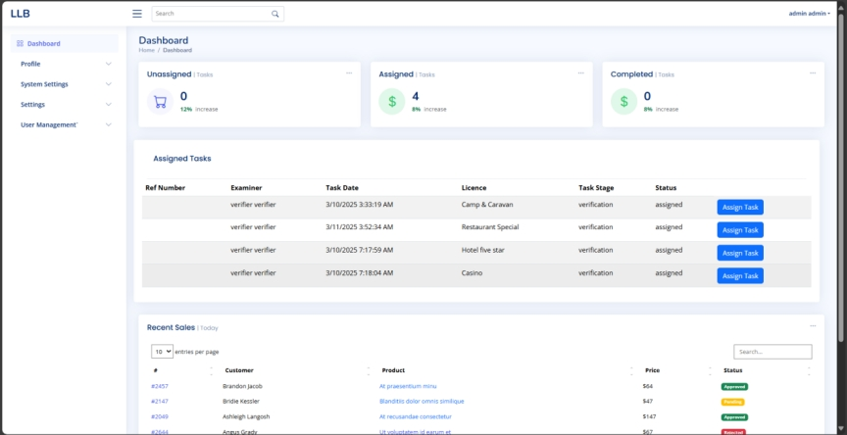

**Navigation Panel**

The left sidebar contains the main navigation options:

**Dashboard**: This is the main interface of the system, providing an overview of tasks and activities. It includes key performance indicators such as the number of unassigned, assigned, and completed tasks. The dashboard allows users to quickly assess task progress and take necessary actions like assigning tasks, tracking completion rates, and monitoring performance trends.

**Profile**: This section allows users to manage their personal information, including updating their name, email address, and other relevant details. Users may also have the option to change their passwords, upload profile pictures, or configure notification preferences. Maintaining an updated profile ensures better user identification and security within the system.

**System Settings**: This section provides configuration options to adjust the overall behavior of the system. Users with administrative privileges can modify system preferences such as task allocation rules, notification settings, security protocols, and other operational parameters. Proper configuration of system settings ensures that the platform runs efficiently and meets the organization's requirements.

**Settings**: This section contains additional system options that allow users to fine-tune specific functionalities. It may include general settings, appearance customization, integration with external tools, and other configurations that enhance user experience and system usability.

**User Management**: This section is dedicated to managing users and their permissions. Administrators can add new users, assign roles, modify existing user access levels, and remove users when necessary. It helps in ensuring that each user has the right permissions based on their responsibilities. This section also allows administrators to track user activities, ensuring security and compliance with company policies.

#### 7.3 Task Summary

**Unassigned Tasks**

This section displays the total number of tasks that have not yet been assigned to an examiner or verifier. These tasks are pending allocation and require an administrator or relevant personnel to assign them. Keeping track of unassigned tasks helps ensure that no tasks are left unattended and that work is distributed efficiently among available examiners.

**Assigned Tasks**

This section provides an overview of the number of tasks that have been successfully assigned to examiners. It includes a percentage increase or decrease, showing the fluctuation in task allocation over time. Monitoring assigned tasks helps supervisors gauge workload distribution and ensures that all tasks are progressing as expected.

**Completed Tasks**

This section displays the total number of tasks that have been completed. It also provides a percentage increase or decrease, indicating trends in task completion rates. Keeping track of completed tasks helps assess overall productivity and efficiency, ensuring that tasks move through the workflow in a timely manner.

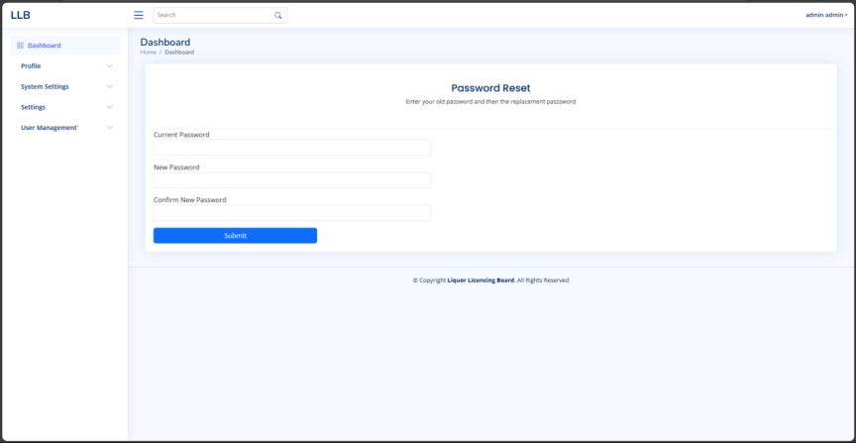

#### 7.4 Password Reset

The Password Reset feature allows users to change their password securely. Follow these steps to reset your password:

1. Navigate to the Password Reset Page: Click on the admin admin dropdown in the top right corner of the dashboard. and Select Password Reset from the menu.
2. Enter Current Password: In the Current Password field, type your existing password.
3. Enter New Password: In the New Password field, enter your desired password. Ensure it meets security requirements, such as a combination of uppercase and lowercase letters, numbers, and special characters.
4. Confirm New Password: Re-enter the same new password in the Confirm New Password field to avoid mistakes.
5. Submit the Request: Click the Submit button to save the changes and If the current password is correct and the new passwords match, your password will be updated successfully.
6. Login with the New Password: After resetting, log in again using your new credentials to confirm the change.

If you encounter any issues during the reset process, contact the system administrator for assistance.

#### 7.5 Council Management in the LLB System

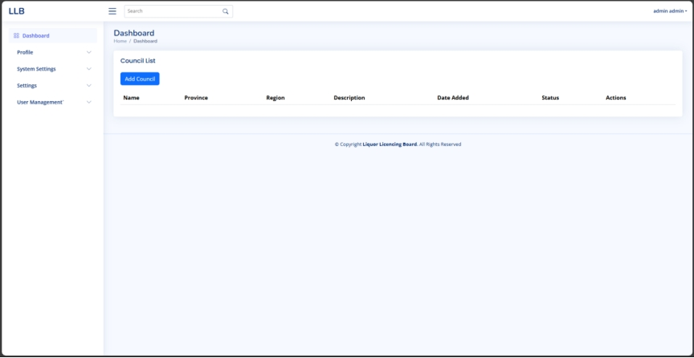

The Liquor Licensing Board (LLB) system incorporates a "Council" module designed for managing regional governing bodies responsible for liquor licensing.

Each council entry includes key details like name, province, region, description, date added, and status, with corresponding action options. Administrators can utilize the "Add Council" functionality to register new councils by inputting essential information such as council name, province, region, description, and status (active/inactive), thereby ensuring systematic addition and monitoring for efficient governance and regulatory oversight of liquor licensing activities.

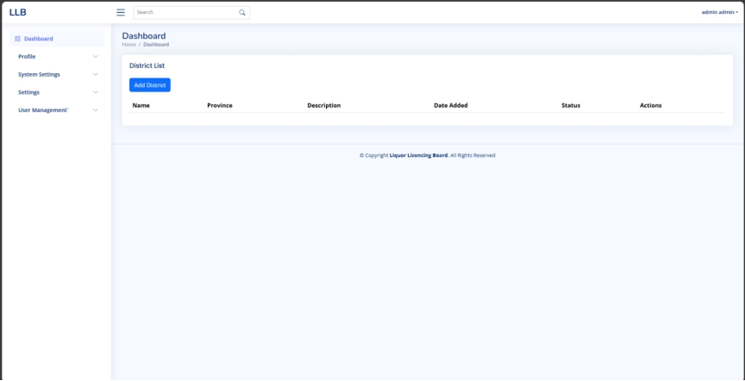

In the given Liquor Licensing Board (LLB) system interface:

1. **District**
   * A district likely represents a governing or regulatory body responsible for managing liquor licensing in a particular province or region.
   * It may contain details like name, province, region, description, date added, status, and relevant actions.
2. **Add Council**
   * The "Add Council" button is available for administrators to register a new council.
   * Clicking this button may open a form to input details such as:
     + Council Name
     + Province
     + Region
     + Description
     + Status (Active/Inactive)
     + Other relevant metadata.
   * This feature ensures that new councils can be systematically added and monitored, facilitating efficient governance and regulatory oversight of liquor licensing activities.

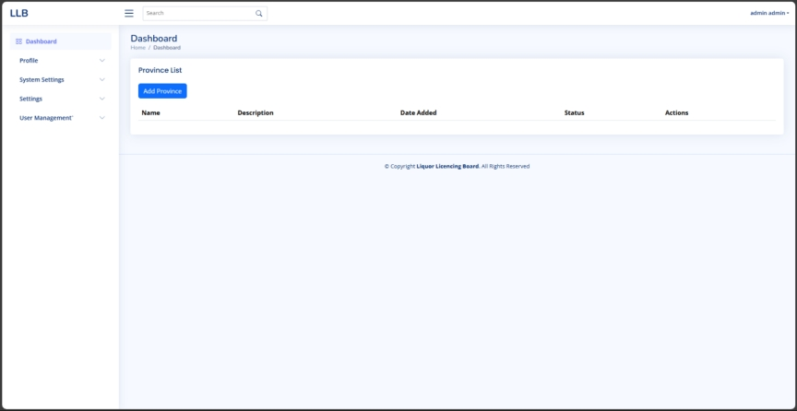

The **Province** section in the Liquor Licensing Board (LLB) system is designed for managing provinces where liquor licensing regulations apply. This section likely includes province-specific details such as the province name, a description, the date it was added, its status (active or inactive), and actions for administrators to manage the data.

The **Add Province** button allows administrators to add a new province to the system. Clicking this button may open a form that requires input fields such as:

* Province Name
* Description
* Status (Active/Inactive)

This feature ensures that all provinces involved in liquor licensing governance are properly recorded and managed.

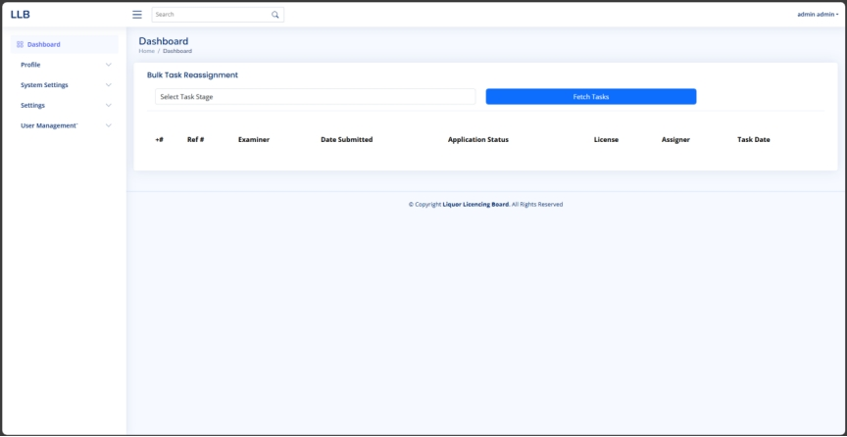

The Bulk Task Reassignment section in the Liquor Licensing Board (LLB) system allows administrators to efficiently manage and reassign multiple tasks related to liquor licensing. This feature likely helps in redistributing workloads among examiners or other relevant personnel.

### **Key Functionalities:**

1. Task Stage Selection:
   * A dropdown menu allows users to select a specific task stage to filter tasks that require reassignment.
2. Fetch Tasks Button:
   * Once a task stage is selected, clicking this button retrieves the corresponding tasks from the system.
3. Task List Table:
   * Displays task details including:
     + Reference Number
     + Examiner Assigned
     + Date Submitted
     + Application Status
     + License Type
     + Assigner
     + Task Date

This feature streamlines reassignment processes, ensuring smooth workflow management

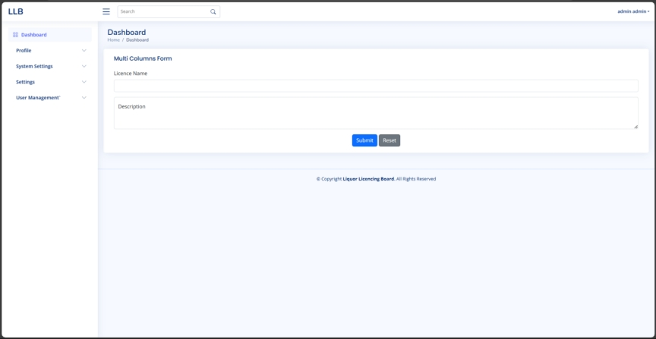

This image shows the dashboard for CREATE LIECENCE it is used to create a licence type to accommodate a specific function or resolve an omitted action when entering the licences available and the description is used to identify the main purpose of the licence being presented to the system

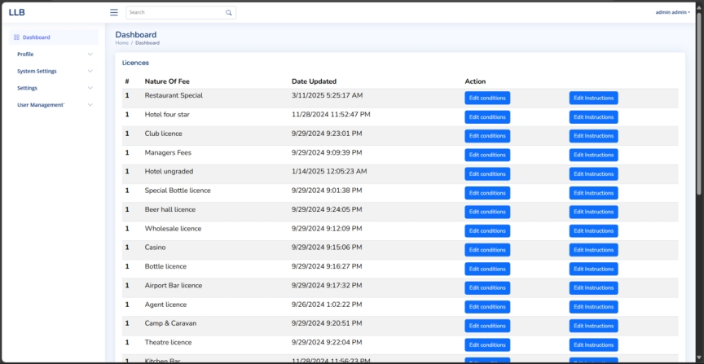

The dashboard displays a table listing various liquor licenses with the following columns:

* **Nature of Fee:** The type of liquor license (e.g., Restaurant Special, Club License, etc.).
* **Date Updated:** The last modification timestamp for each license.
* **Action:** Options to **Edit Conditions** or **Edit Instructions** for each license.

Users can:

* Click **Edit Conditions** to update licensing requirements.
* Click **Edit Instructions** to modify guidelines associated with the license. 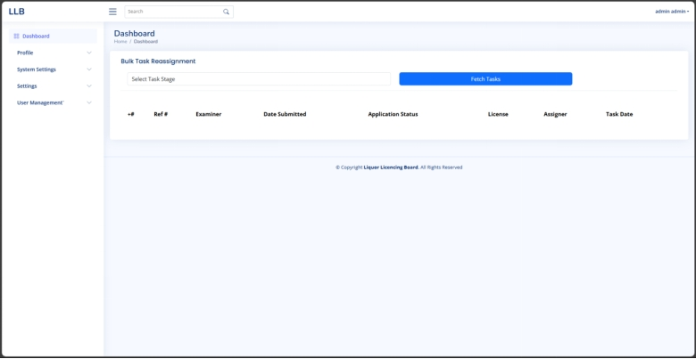

## **Bulk Task Reassignment Dashboard**

### **Overview:**

This section allows bulk reassignment of licensing tasks by selecting a specific task stage and fetching related tasks.

### **Features:**

* Select task stage for reassignment.
* View task details such as reference number, examiner, submission date, application status, and assigner.
* Fetch tasks based on selected criteria.

### **How to Use:**

1. Navigate to the "Bulk Task Reassignment" section under the dashboard.
2. Use the dropdown menu to select the task stage.
3. Click "Fetch Tasks" to load relevant tasks.

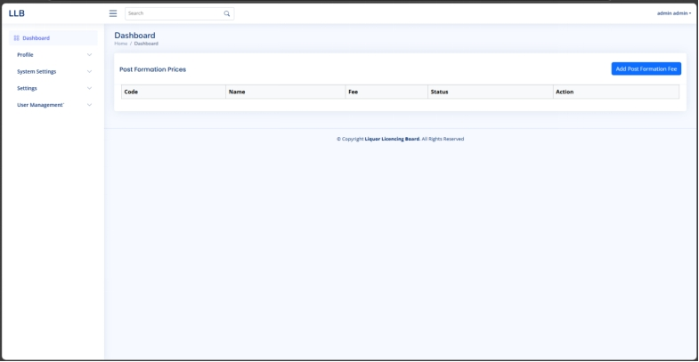

#### Post Formation Prices Dashboard

This section manages Post Formation Fees. It displays a table where users can view or add fees related to post formation licensing.

### **Features:**

* View existing post formation prices.
* Add new post formation fees.

### **How to Use:**

1. Navigate to "Dashboard."
2. Locate the "Post Formation Prices" section.
3. Click the "Add Post Formation Fee" button to enter a new fee.

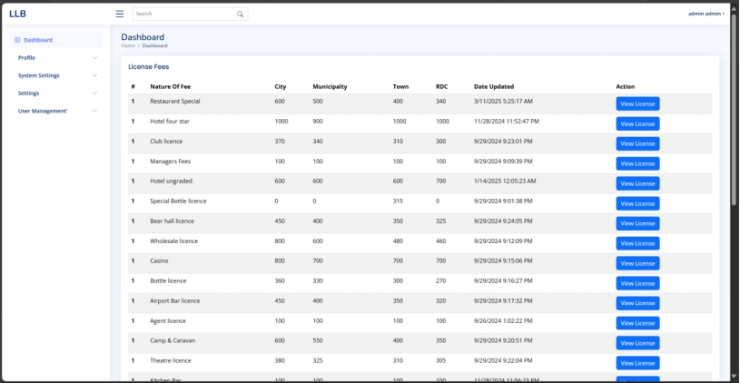

#### License Fees Dashboard

**Overview:**

The License Fees Dashboard displays a table of various liquor license fees categorized by City, Municipality, Town, and Rural District Council (RDC). Users can view detailed license information by clicking the "View License" button.

**Features:**

* View different license types and their associated fees.
* Check the last updated date for each fee category.
* Access detailed license information via the "View License" button.

**How to Use:**

1. Navigate to the "Dashboard" section.
2. Scroll through the "License Fees" table to view available licenses.
3. Click "View License" next to a license to access more details.

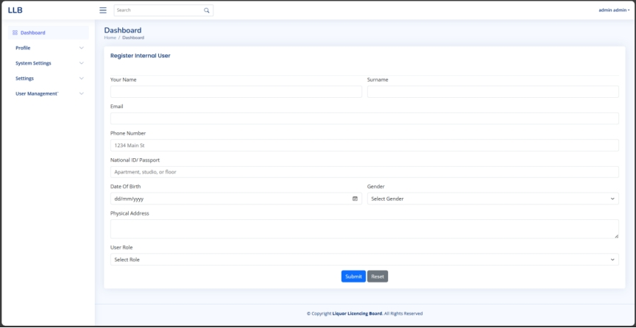

The "Register Internal User" section allows administrators to add new users to the system by entering their personal and role-specific details.

### **Steps to Register a New User**

#### **1. Fill in User Information**

1. Enter the user's full name (First Name and Surname).
2. Provide an Email Address for login and notifications.
3. Enter a Phone Number for communication purposes.
4. Provide a National ID or Passport Number as an identifier.
5. Select the Date of Birth using the date picker.
6. Choose the User’s Gender from the dropdown.
7. Enter the Physical Address of the user.

#### **2. Assign a User Role**

1. Click on the User Role dropdown.
2. Select the appropriate role (e.g., Accountant, Verifier, Admin).

#### **3. Submit the Registration**

* Click Submit to save the user.
* Click Reset to clear the form.

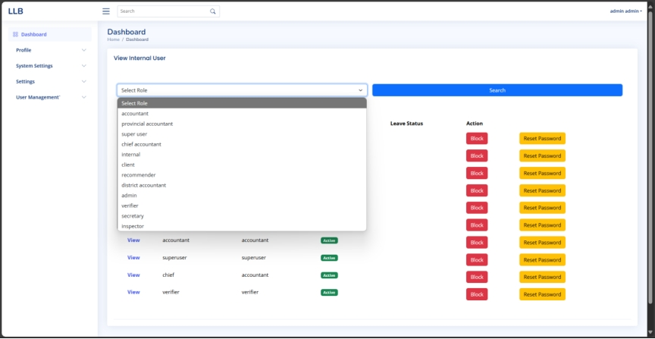

### **Overview**

The "View Internal User" section allows administrators to filter and manage users based on roles, view their leave status, and perform actions such as blocking accounts or resetting passwords.

### **Steps to Use the View Internal User Section**

#### **1. Selecting a User Role**

1. Click on the Select Role dropdown.
2. Choose the role you want to filter users by (e.g., Accountant, Verifier, Admin).
3. Click the Search button to display users with the selected role.

#### **2. Viewing User Details**

* After selecting a role and clicking Search, a list of users matching that role will appear.
* Each row displays the user’s details, including:
  + Role
  + Leave Status (e.g., Active)
  + Actions (Block, Reset Password)

#### **3. Managing User Accounts**

* Block a User: Click the Block button next to a user’s name to disable their account.
* Reset Password: Click the Reset Password button to generate a new password for the user.